Cognizant Technology Solutions



A Project Report on

“FORMULA 1 PROJECT USING PYSPARK”

Prepared By

|  |  |
| --- | --- |
| Ankita Shivane | 2320390 |
| Harshit Yadav | 2320382 |
| Mimansa Yadav | 2320956 |
| Nandhini T | 2320539 |
| Rajanya Kamilya | 2320828 |
| Shambhavi Shukla | 2320529 |

FORMULA RACING

PYSPARK

PySpark is a Python API to support Python with Apache Spark. PySpark provides Py4j library, with the help of this library, Python can be easily integrated with Apache Spark. PySpark plays an essential role when it needs to work with a vast dataset or analyze them. This feature of PySpark makes it a very demanding tool among data engineers.



A large amount of data is generated offline and online. It is necessary to extract valuable information from the raw data. We require a more efficient tool to perform different types of operations on the big data. There are various tools to perform the multiple tasks on the huge dataset, but these tools are not so appealing anymore. It is needed some scalable and flexible tools to crack big data and gain benefit from it.

BUSINESS REQUIREMENTS

**Description:**    
Analyze and process Formula 1 data files to extract insights about dominant drivers, teams and their performances.

**REQUIREMENTS:**

**Data Ingestion Requirements:**

• Ingest the data from various source files

• Ingested data must have the schema applied

• Ingested data must have audit columns

• Ingested data must be stored in a columnar format

**Data Transformation Requirements:**

• Join the key information required for reporting to create a new table.

• Join the key information required for Analysis to create a new table.

• Transformed tables must have audit columns

• Must be able to analyze the transformed data via SQL

• Transformed data must be stored in columnar format (i.e. Parquet)

**Reporting Requirements:**

• Driver Standings

• Constructor Standings

**Analysis Requirements:**

• Dominant Drivers

• Dominant Teams

• Visualize the Outputs

S

PICTORIAL FLOWCHART

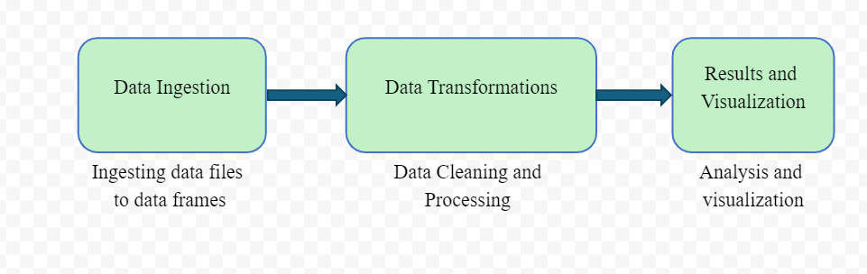

F1 DATA SET

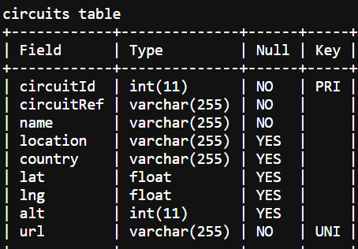

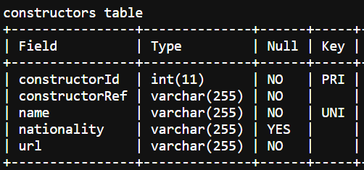

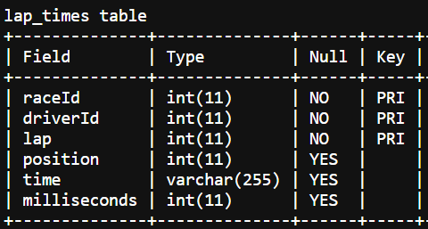

**FK**

**FK**

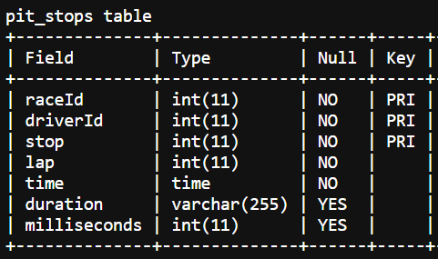

**FK**

**FK**

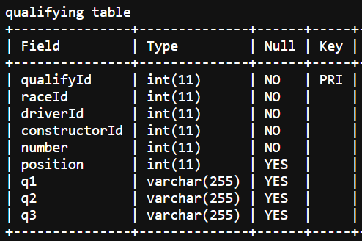

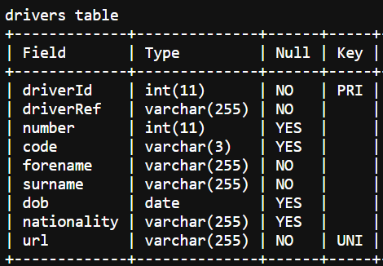

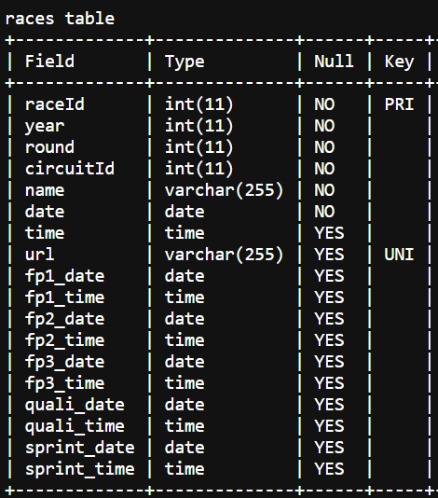

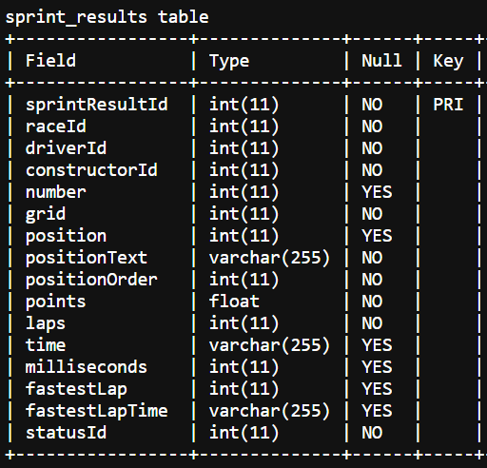

IMPLEMENTATION:

* **REQUIREMENT 1:**

**DATA INGESTION**

Data ingestion is the process of importing and loading data into a system. It’s a critical step in any data-centric workflow, ensuring that the correct information is available at the right time for analysis and decision-making.

To ingest a dataset into Databricks, you can follow these steps:

1. Create a Compute engine:

* Start by creating a Databricks cluster.
* This cluster will provide the compute resources needed to run your commands.

2. Enable DBFS in Databricks:

* Use Databricks features to explore your raw dataset.

3. Ingest the Raw Data:

* Load the raw data into a table to make it available for further processing.

Here, in this project we have 8 datafiles that we need to ingest into dbfs system.

**Circuit file ingestion:**

Step 1: Open Databricks community and login to your account.

Create a compute engine for analysis.

Create new notebook in workspace and write the above syntax

Step 2: Create the schema for Circuit file using StructType

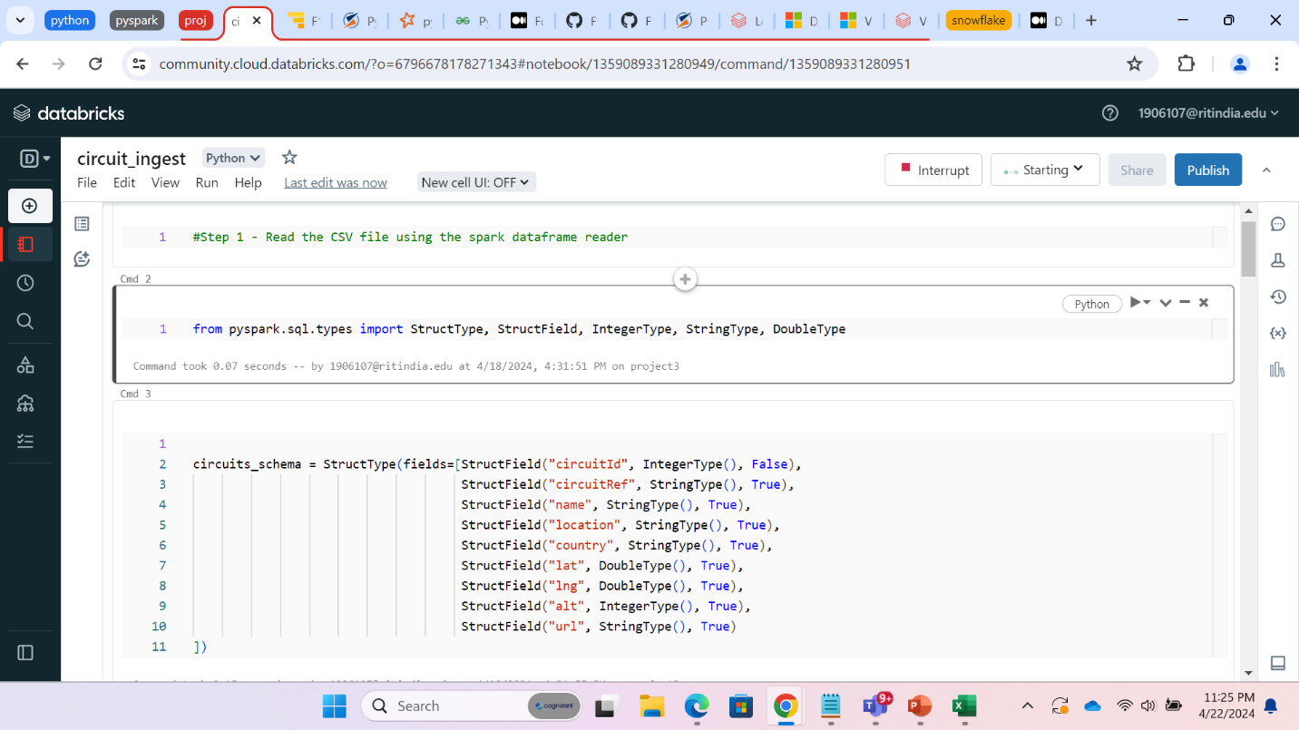

Step 3:We have created a dataframe by reading the data from circuit csv file loaded in DBFS system

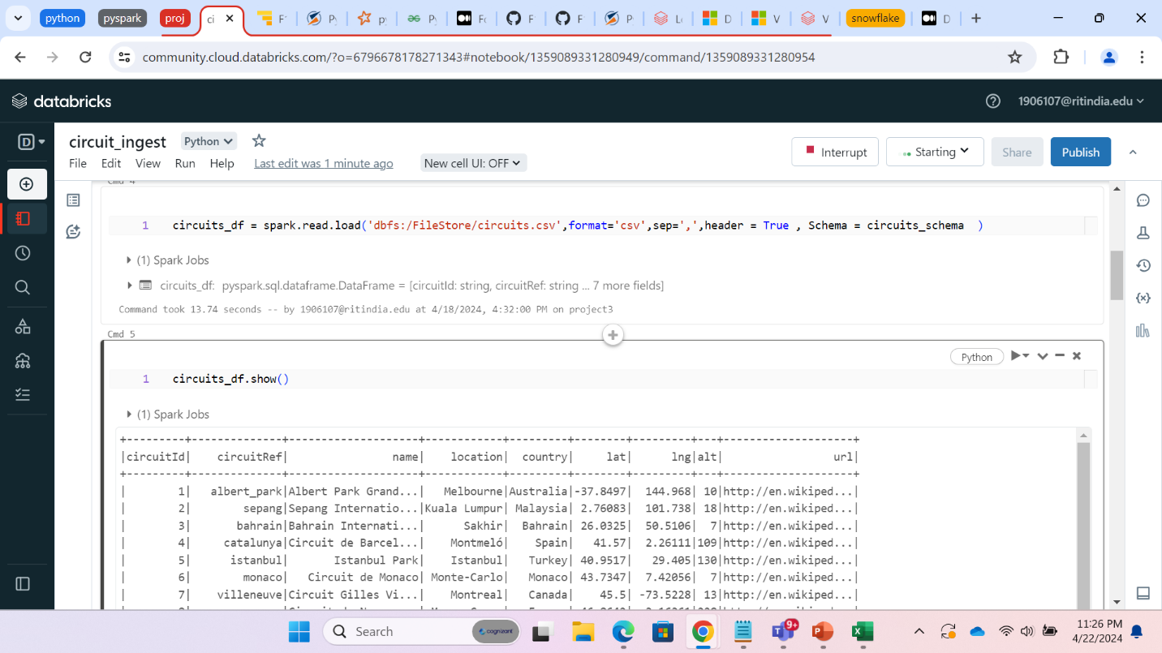

Step 4: Selecting only the required columns and creating a new dataframe.

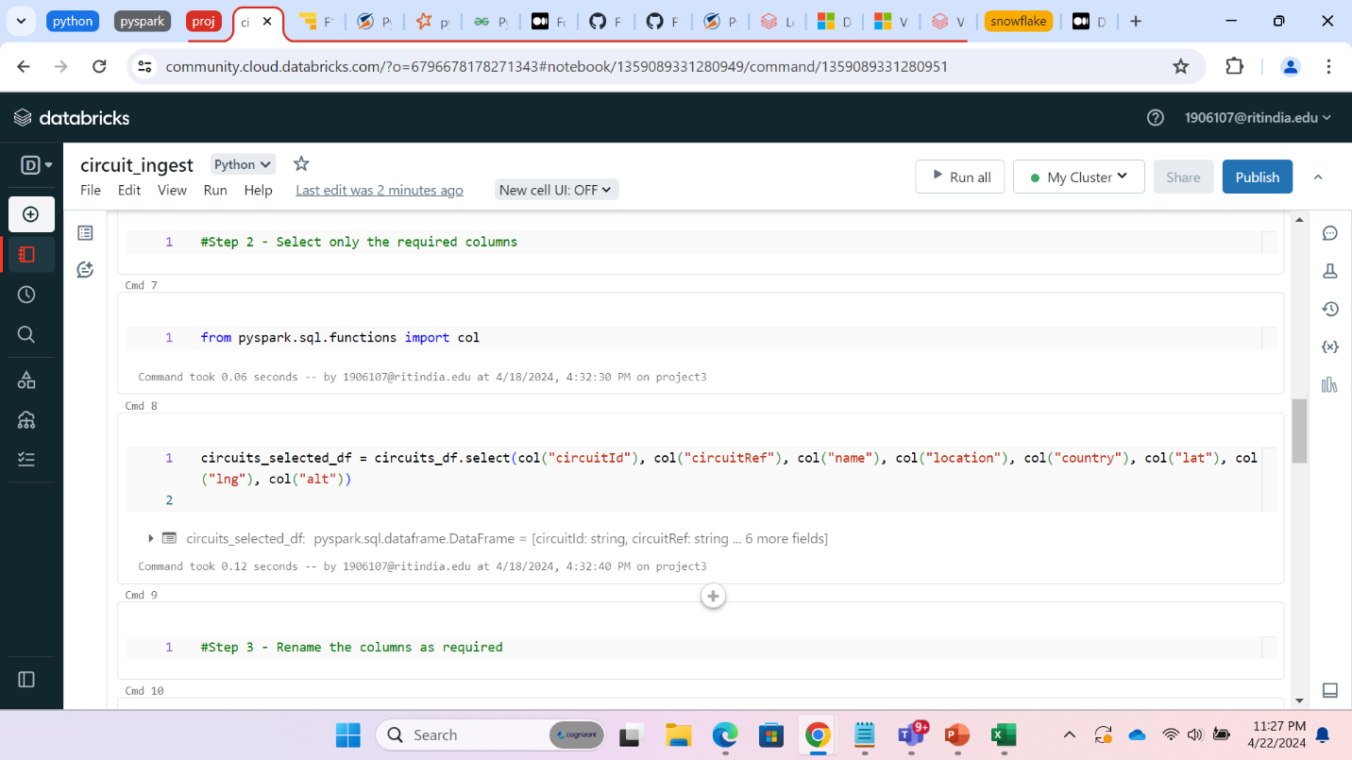

Step 5: Renaming the columns using withColumnRenamed command to match the naming standards.

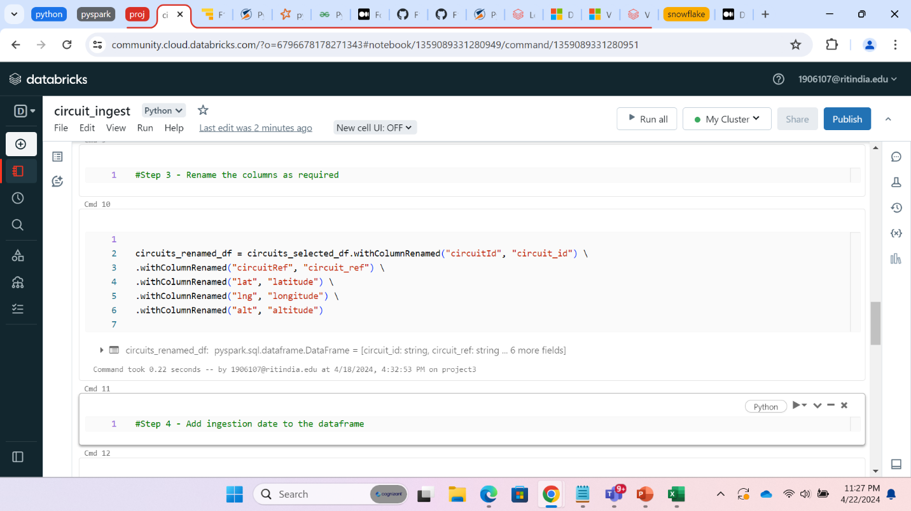

Step 6: Adding the ingestion_date column with current_tiemstamp and displaying the dataframe

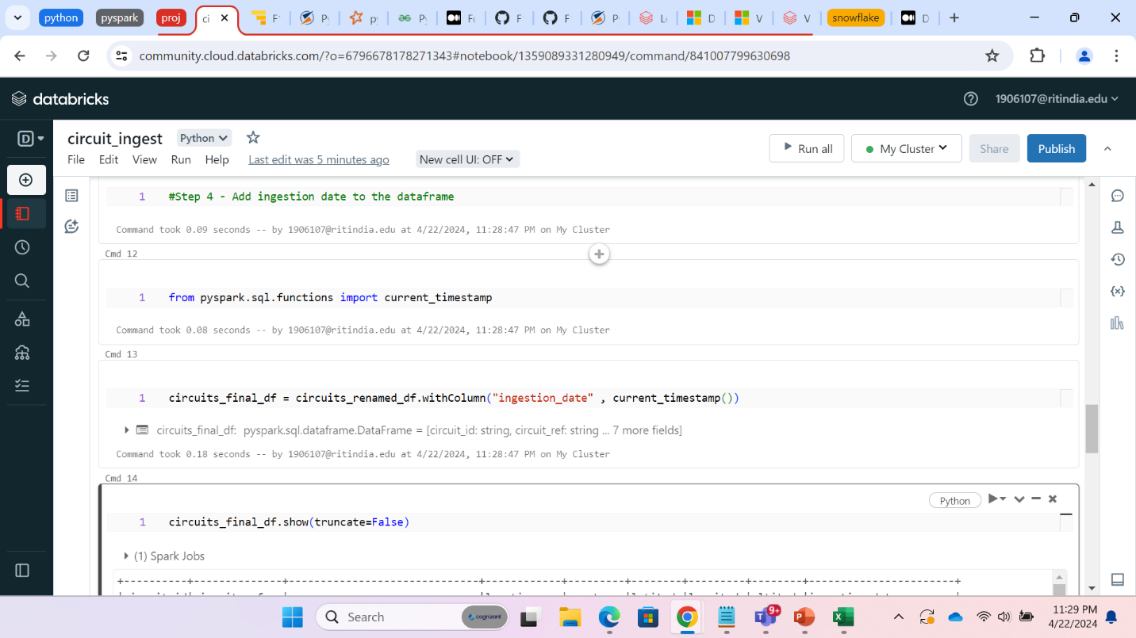

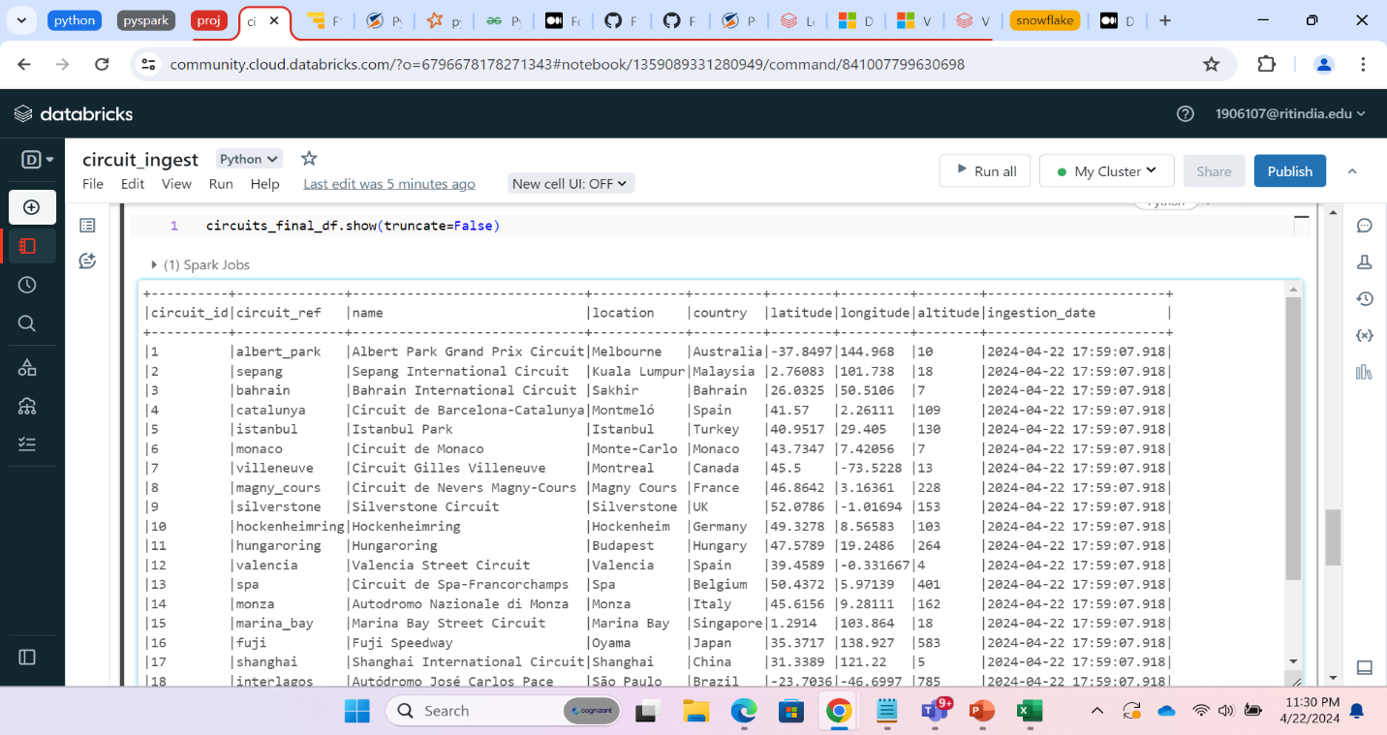

Step 7: Creating new directory in databricks filestore and storing our dataframe in columnar format that is parquet file.

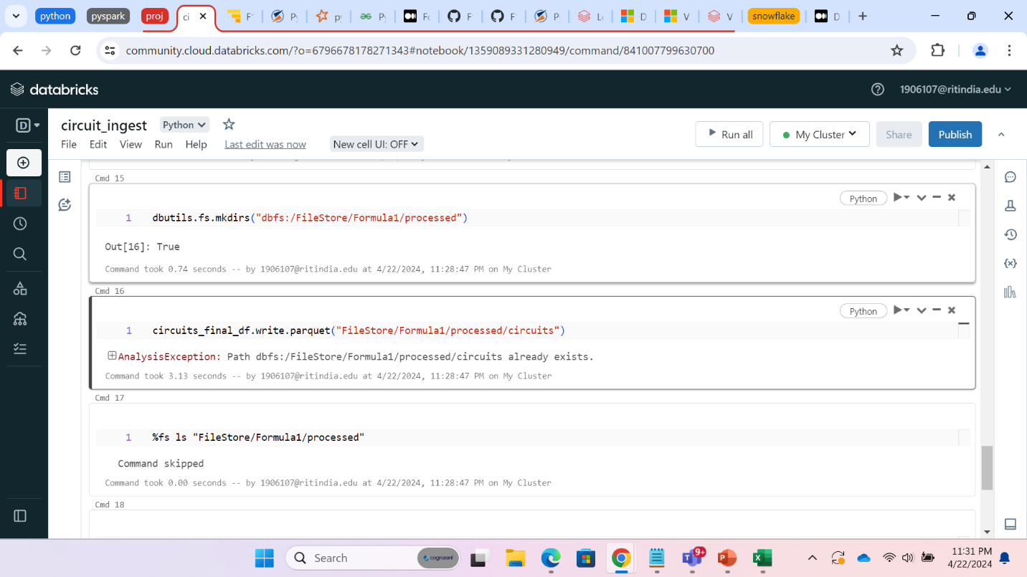

**Constructor file ingestion:**

Step 1: Create the schema for Constructor file using String format and then read the file from constructor json file.

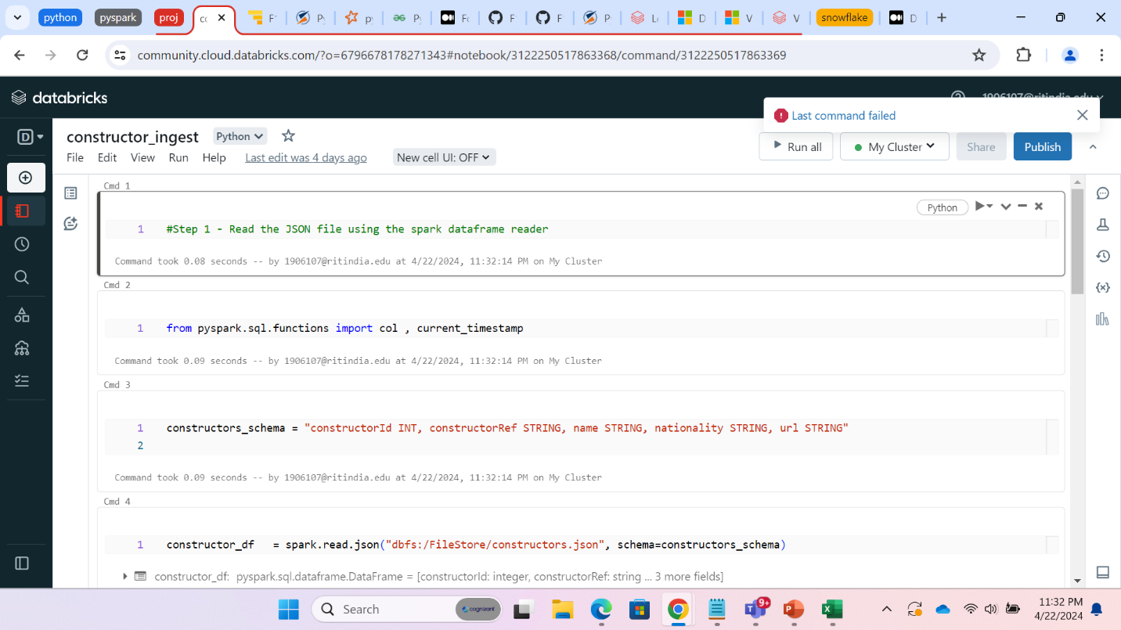

Step2:We are dropping the url column by drop command.

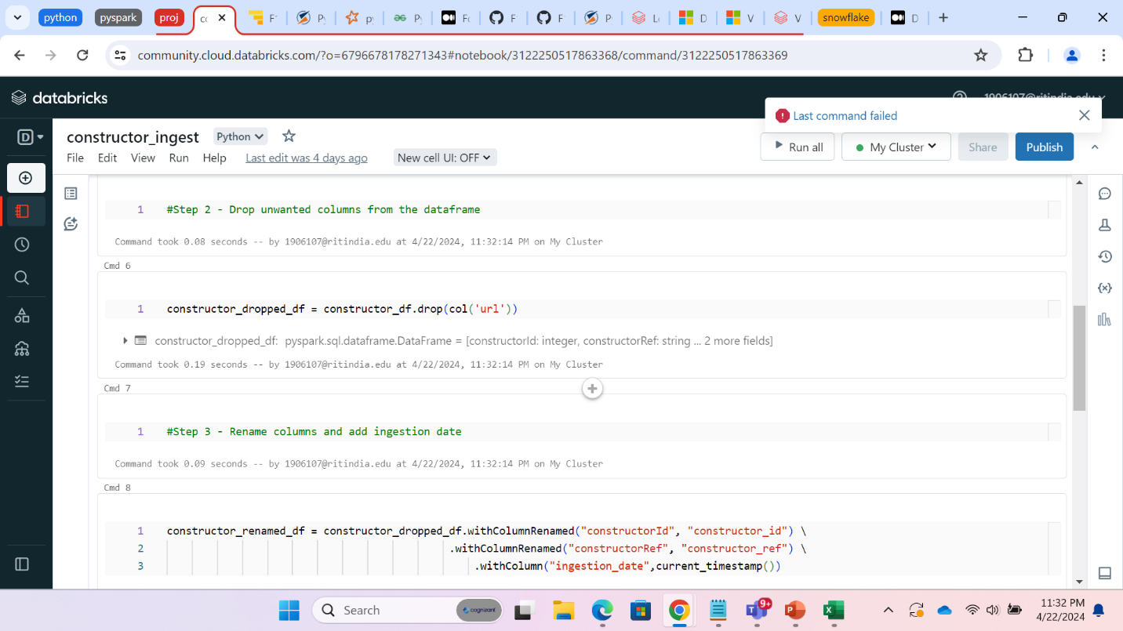

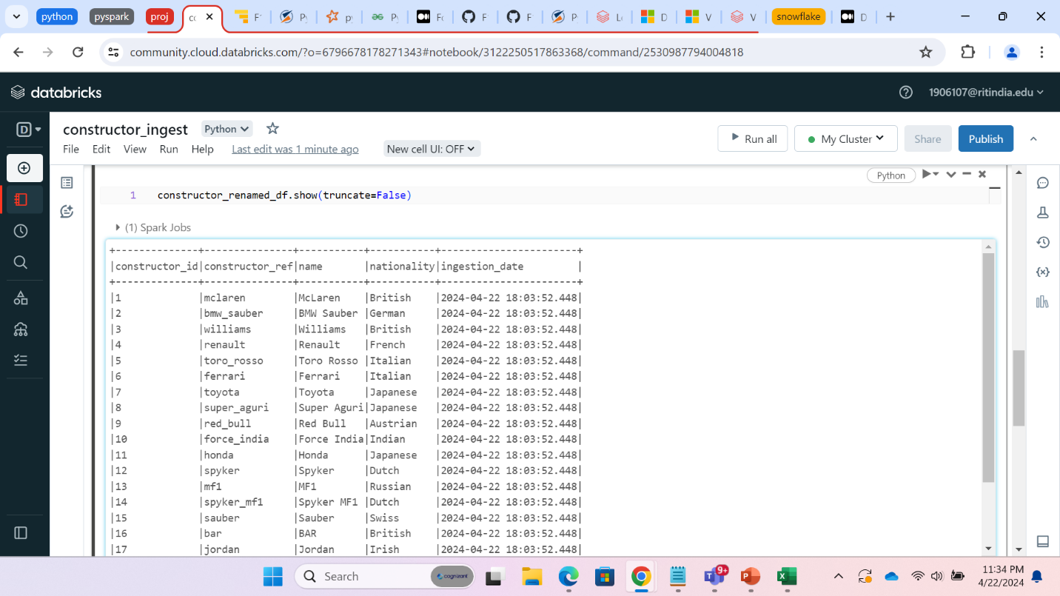

Step3: Storing our dataframe in columnar format that is parquet file.

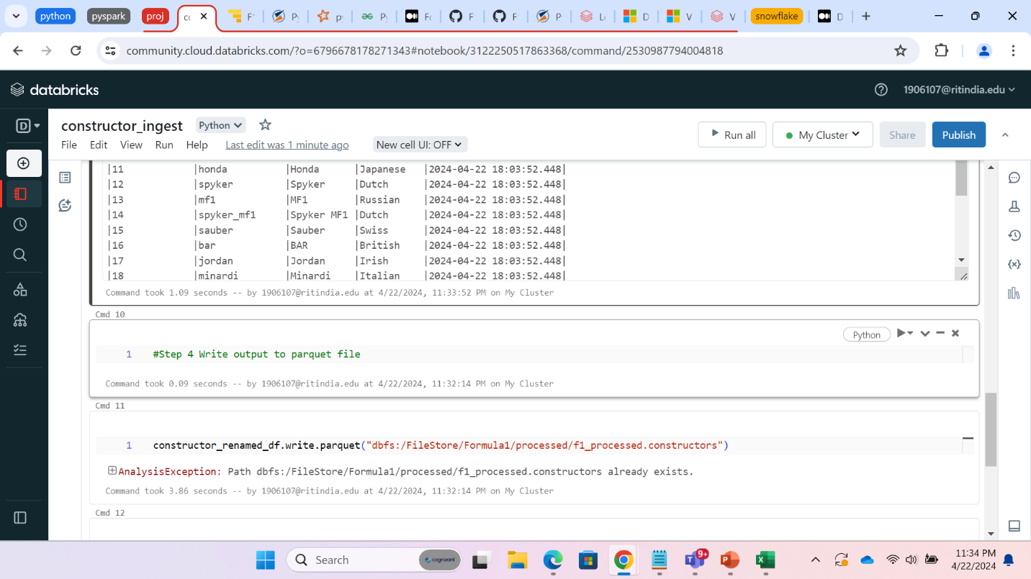

**Driver file ingestion:**

Step 1: Step 2: Create the schema this file using StrucType

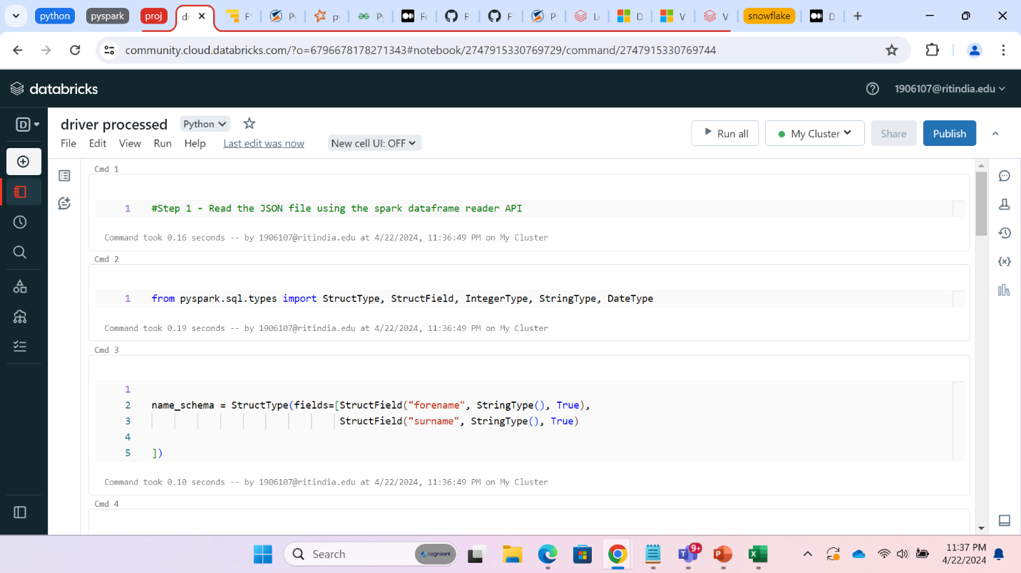

Step 3:We have created a dataframe by reading the data from json file loaded in DBFS system

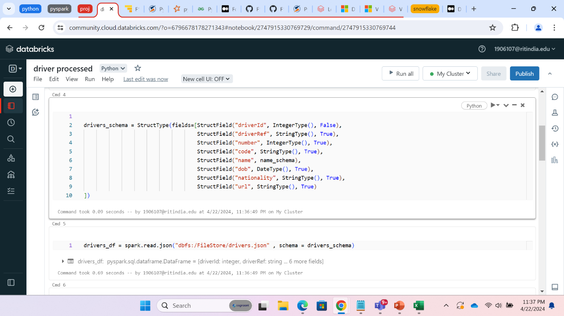

Step 4: Renaming the columns using withColumnRenamed command to match the naming standards.

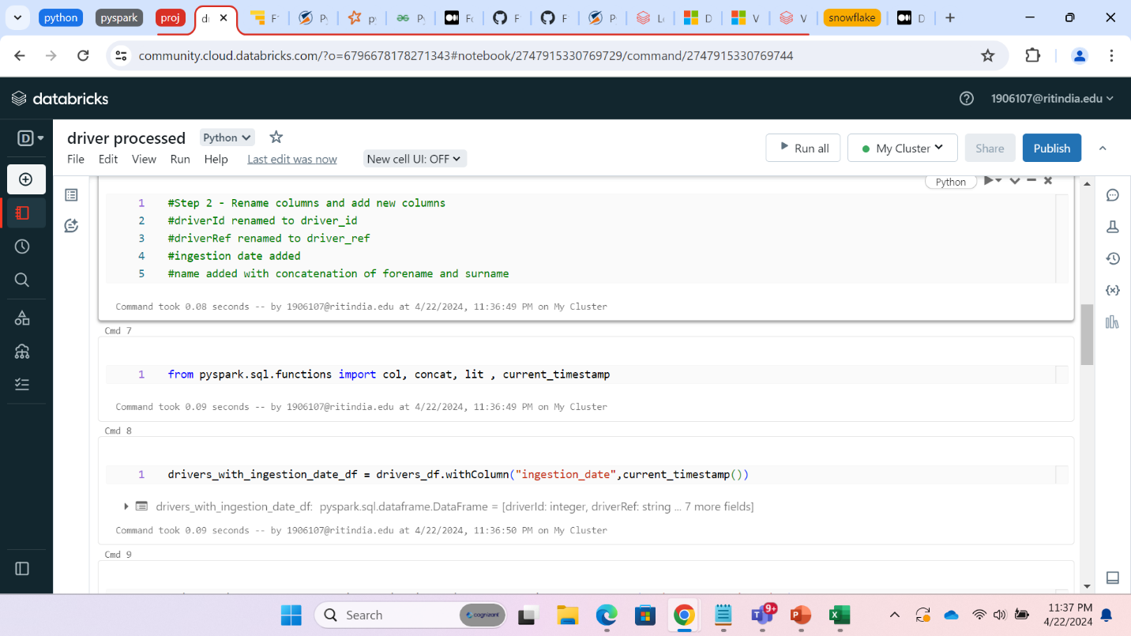

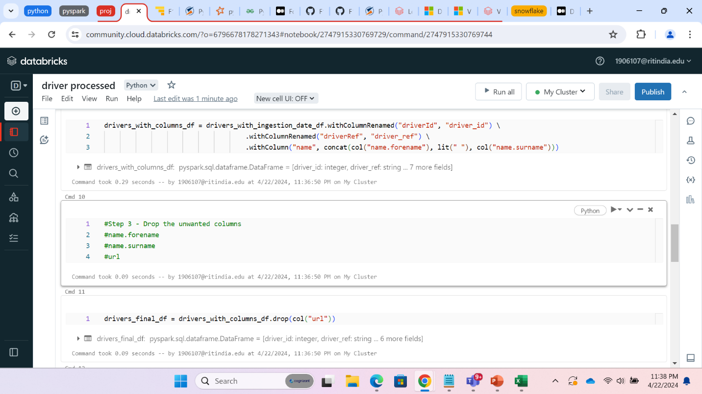

Step 5: Storing our dataframe in columnar format that is parquet file.

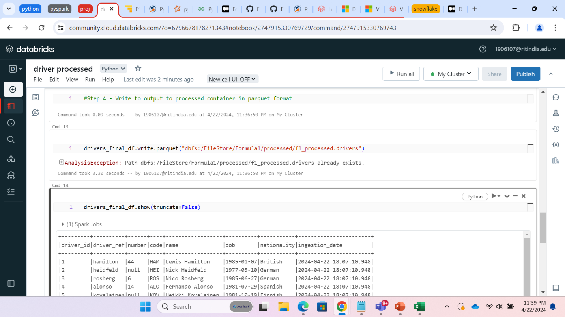

**Similarly, we have performed ingestion on all the other files.**

**LAPTIME INGEST:**

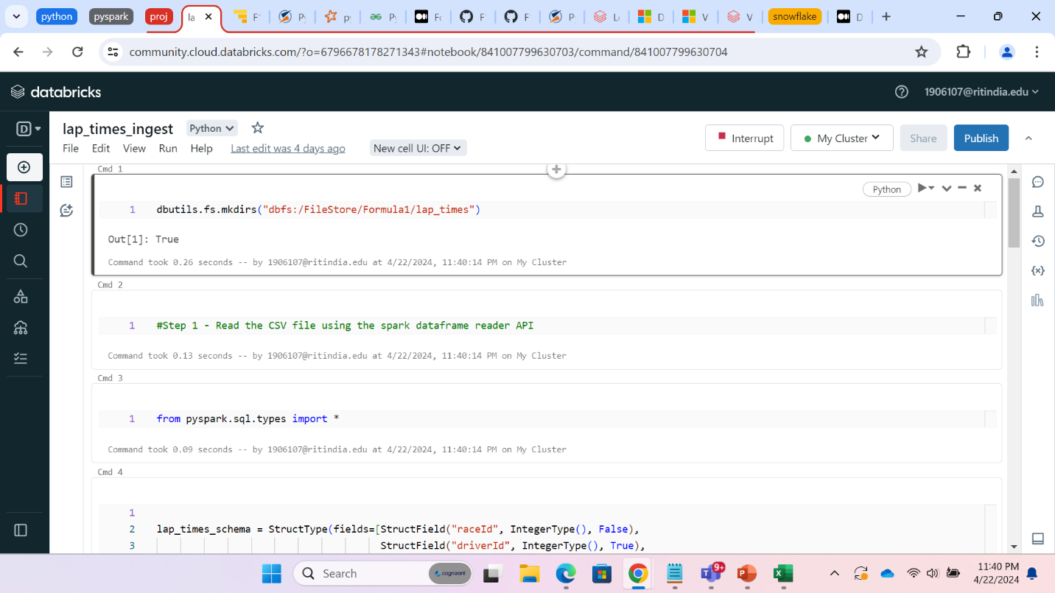

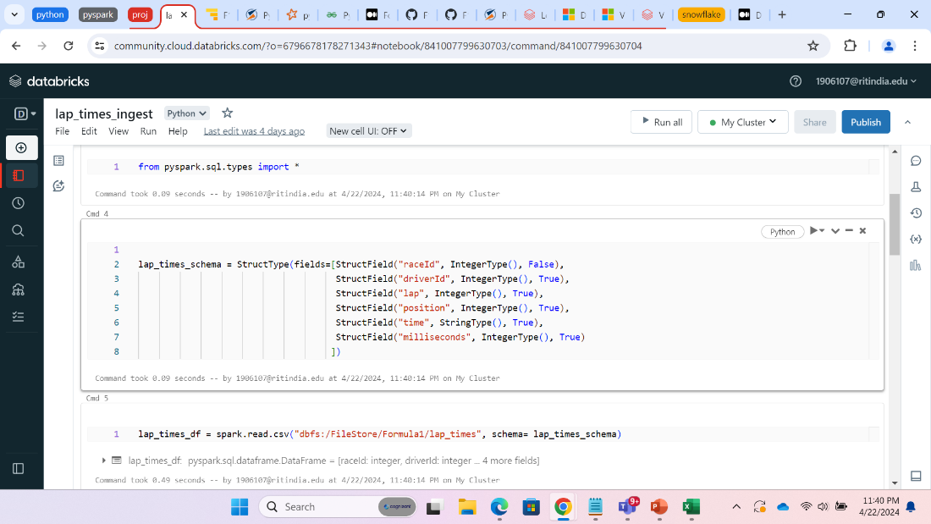

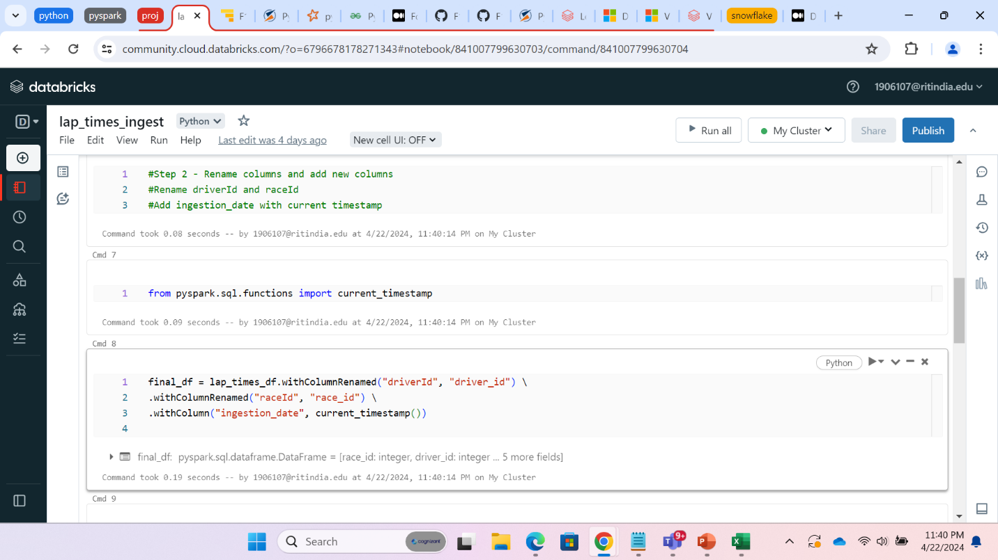

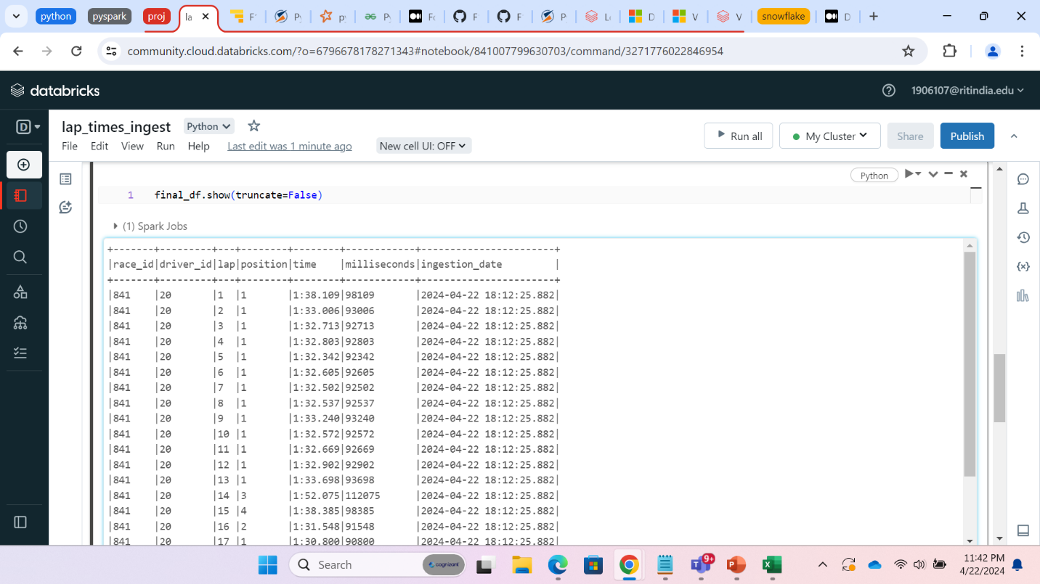

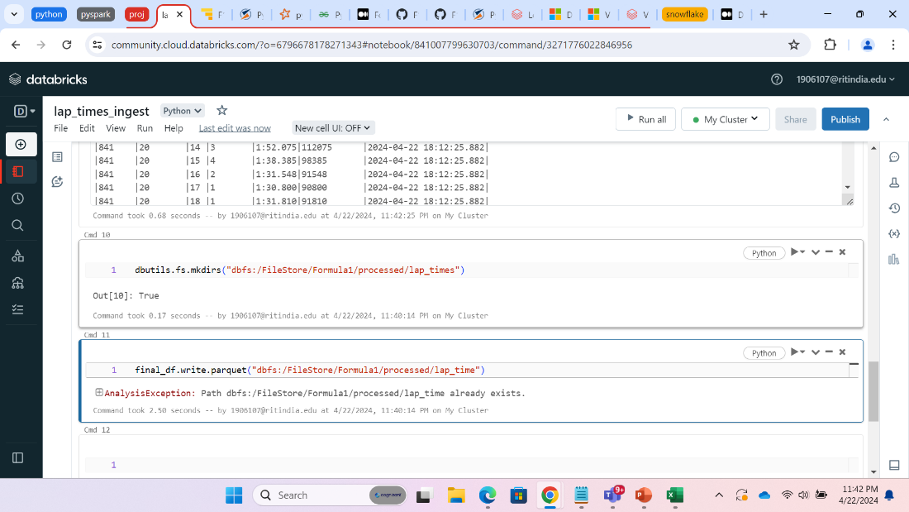

**PIT STOP INGESTION**

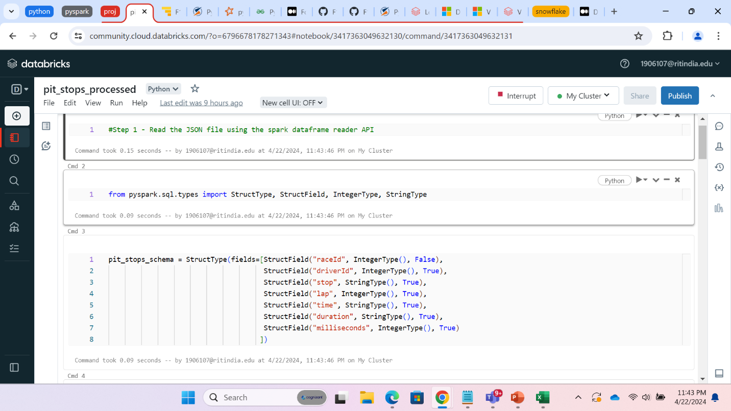

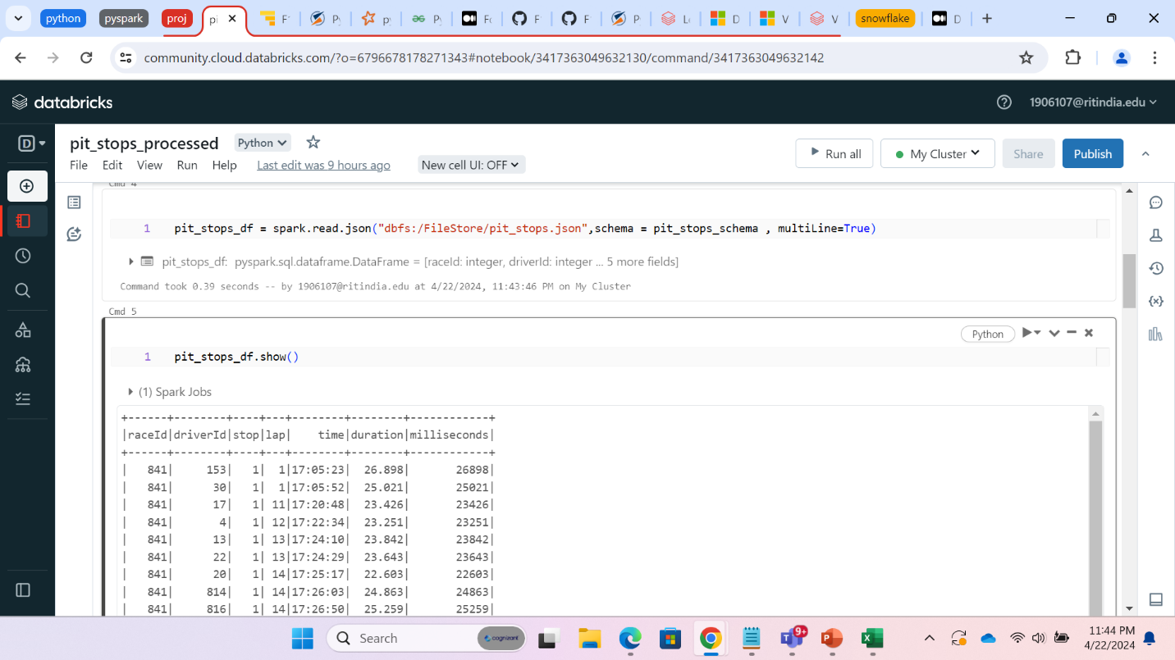

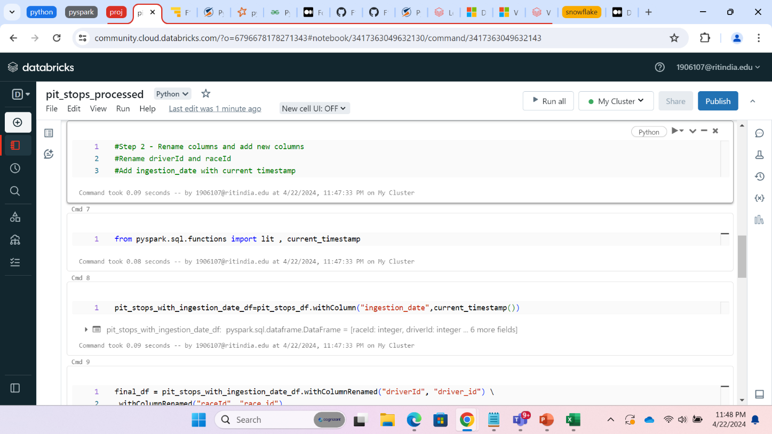

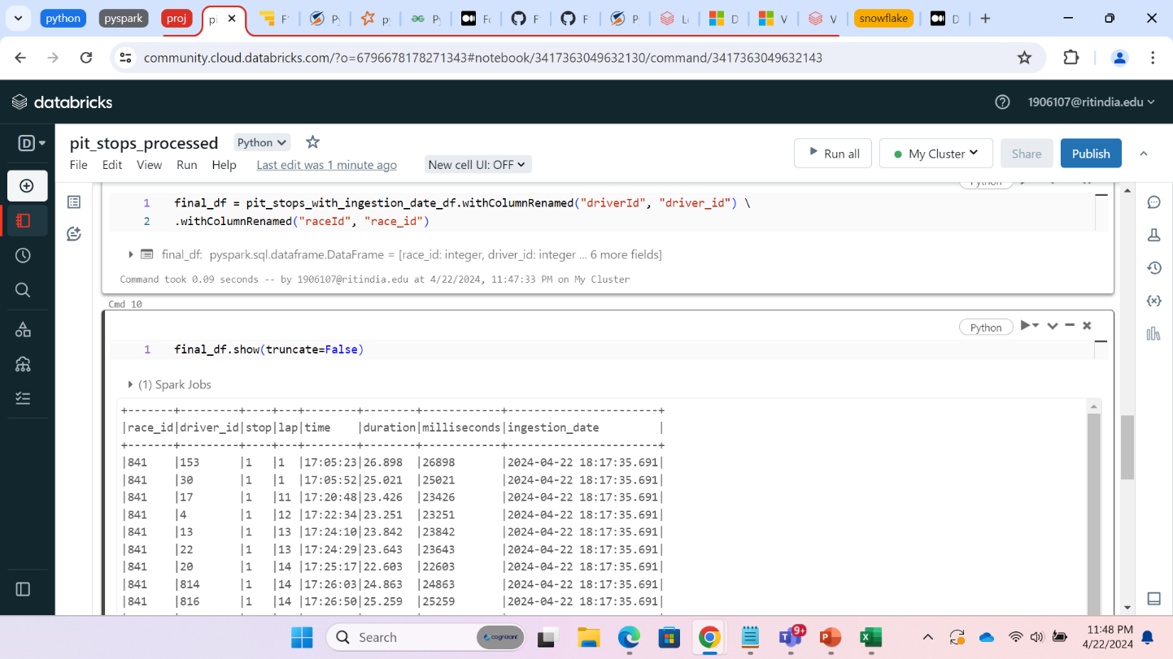

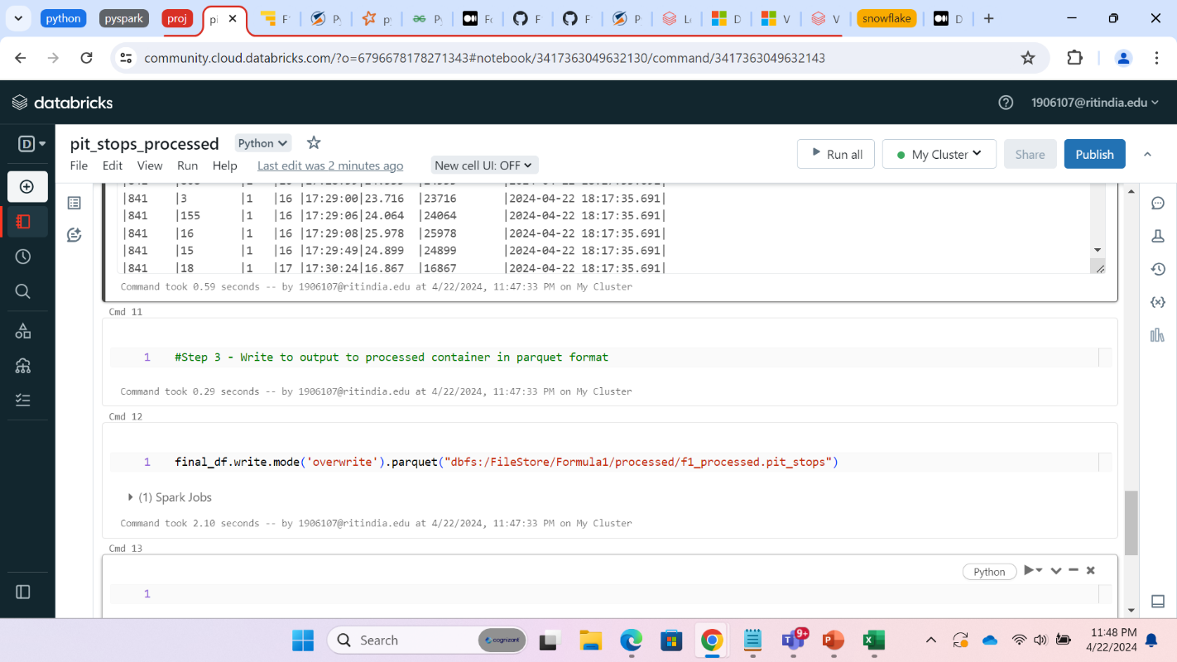

**Qualifying ingest**

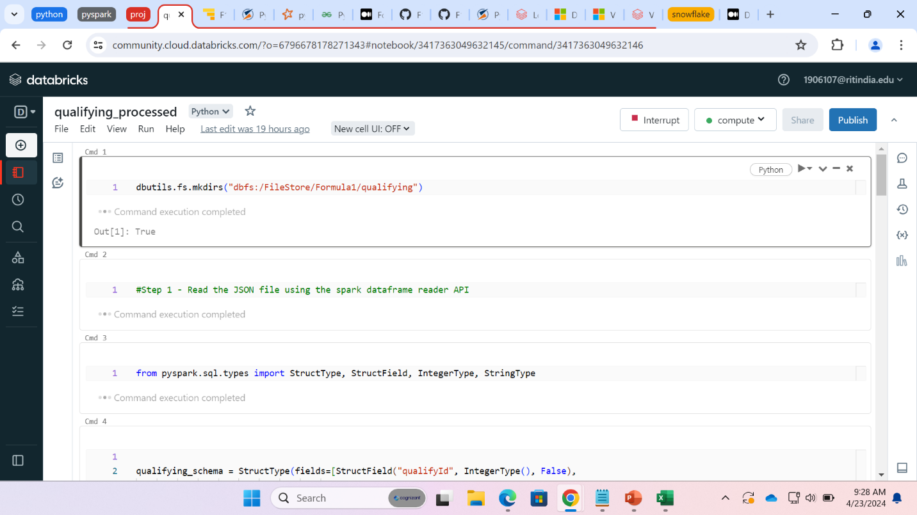

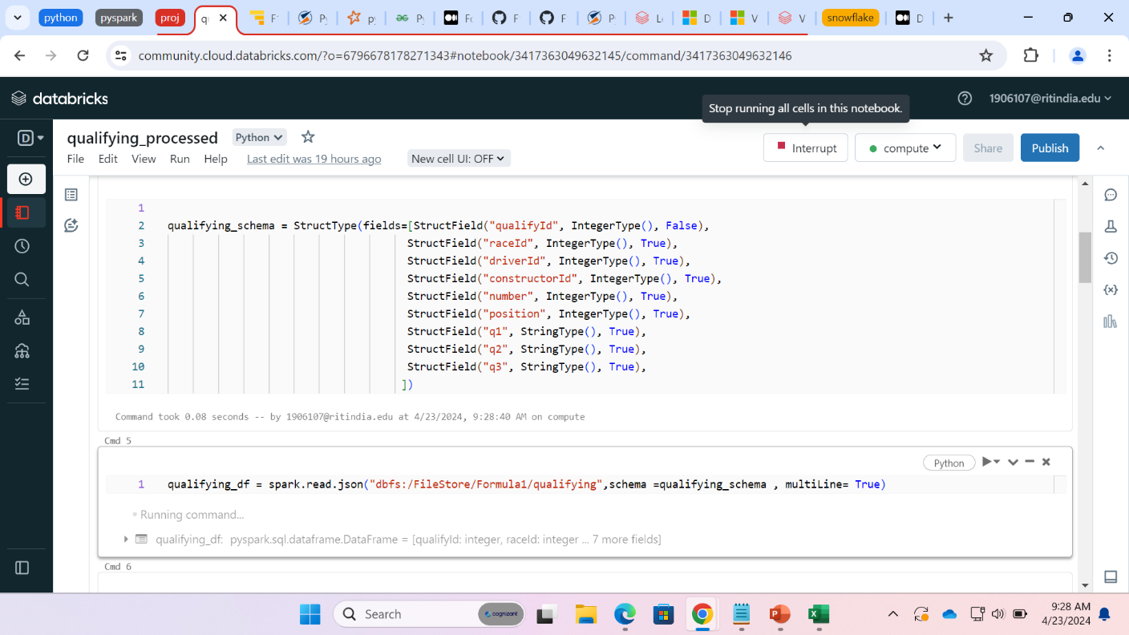

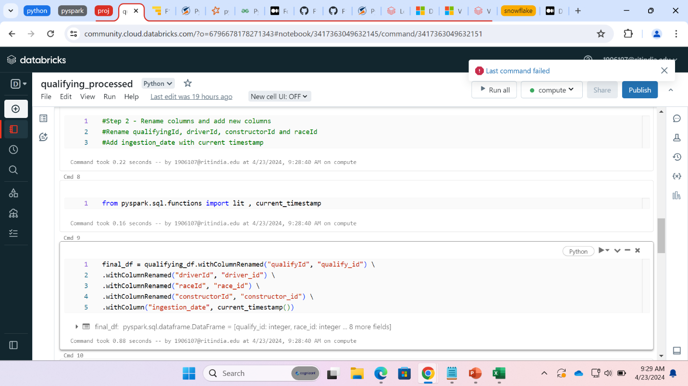

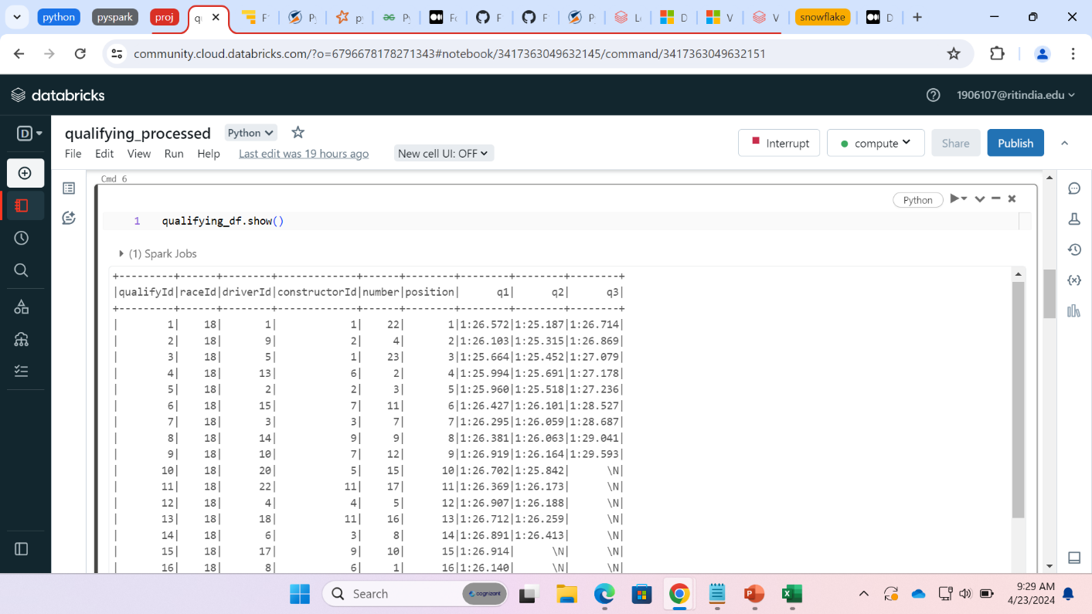

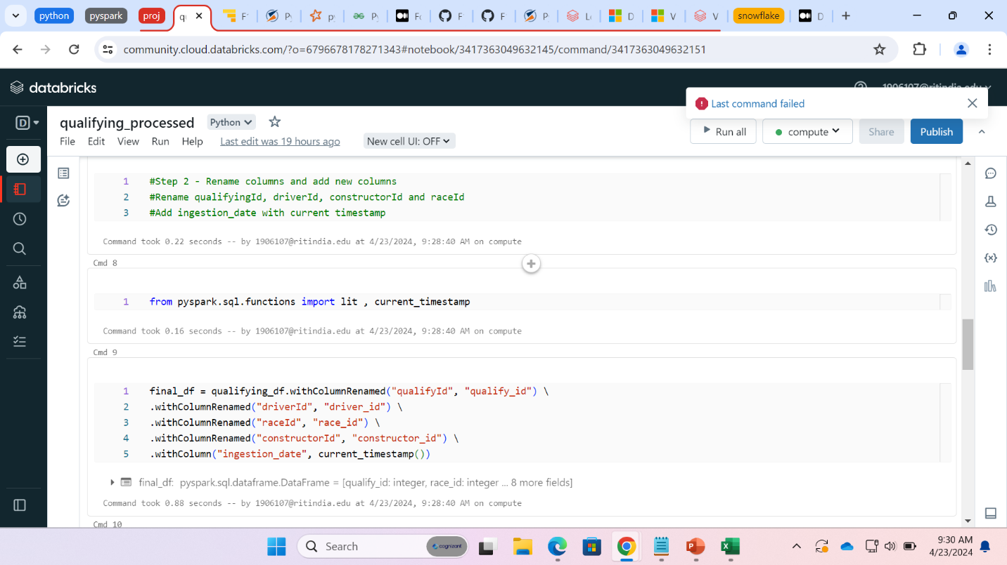

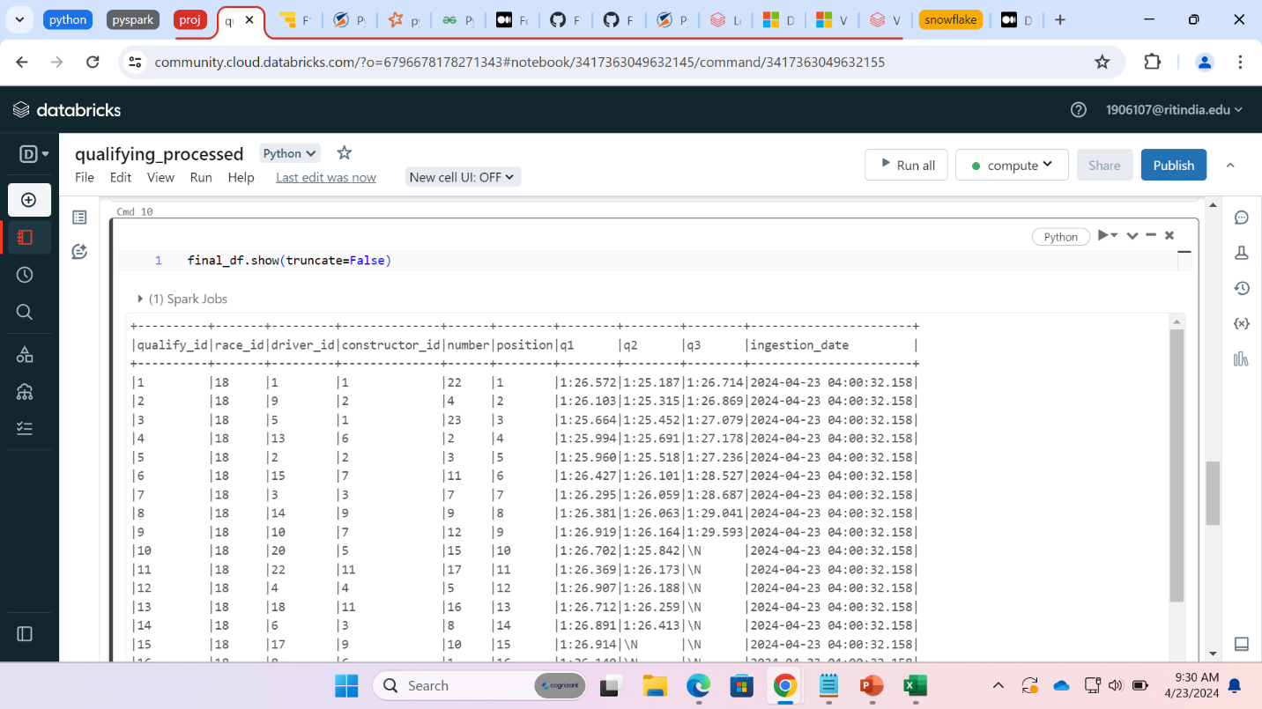

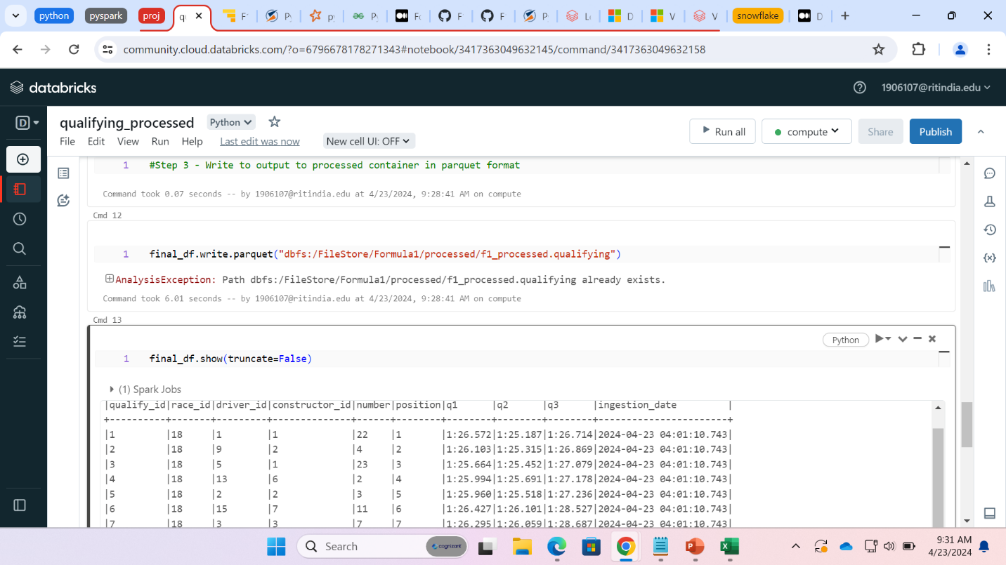

**Race Ingest**

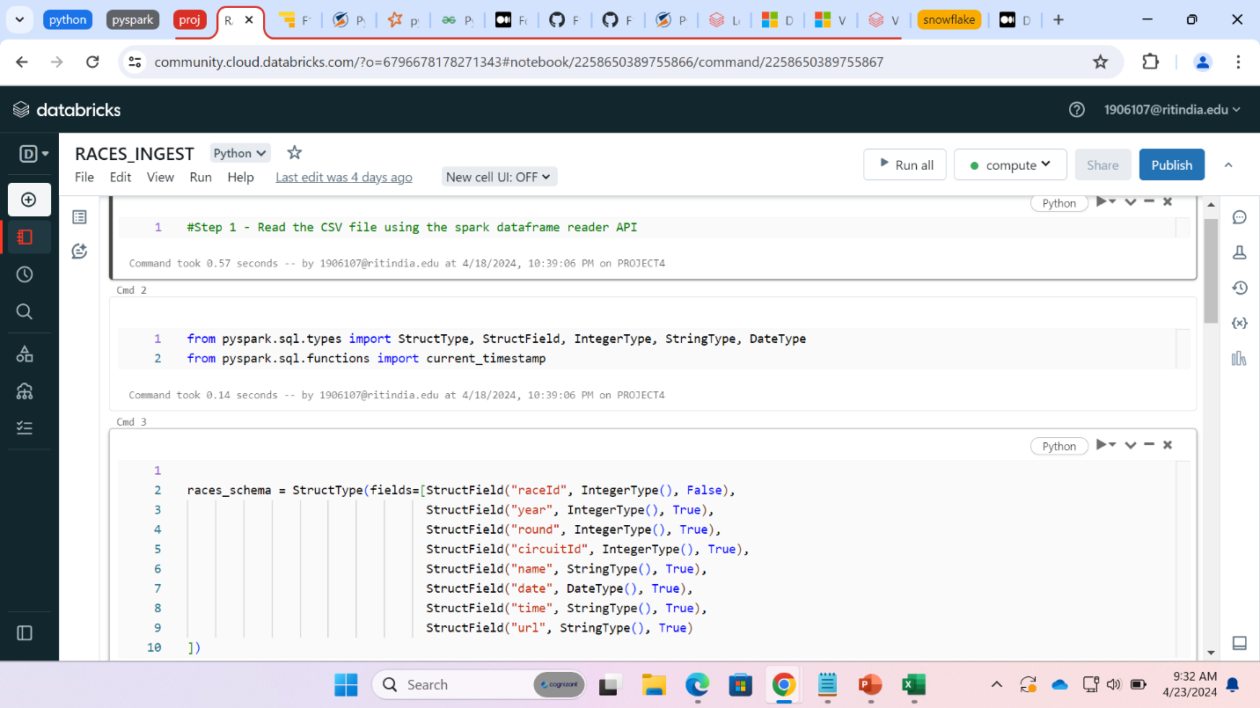

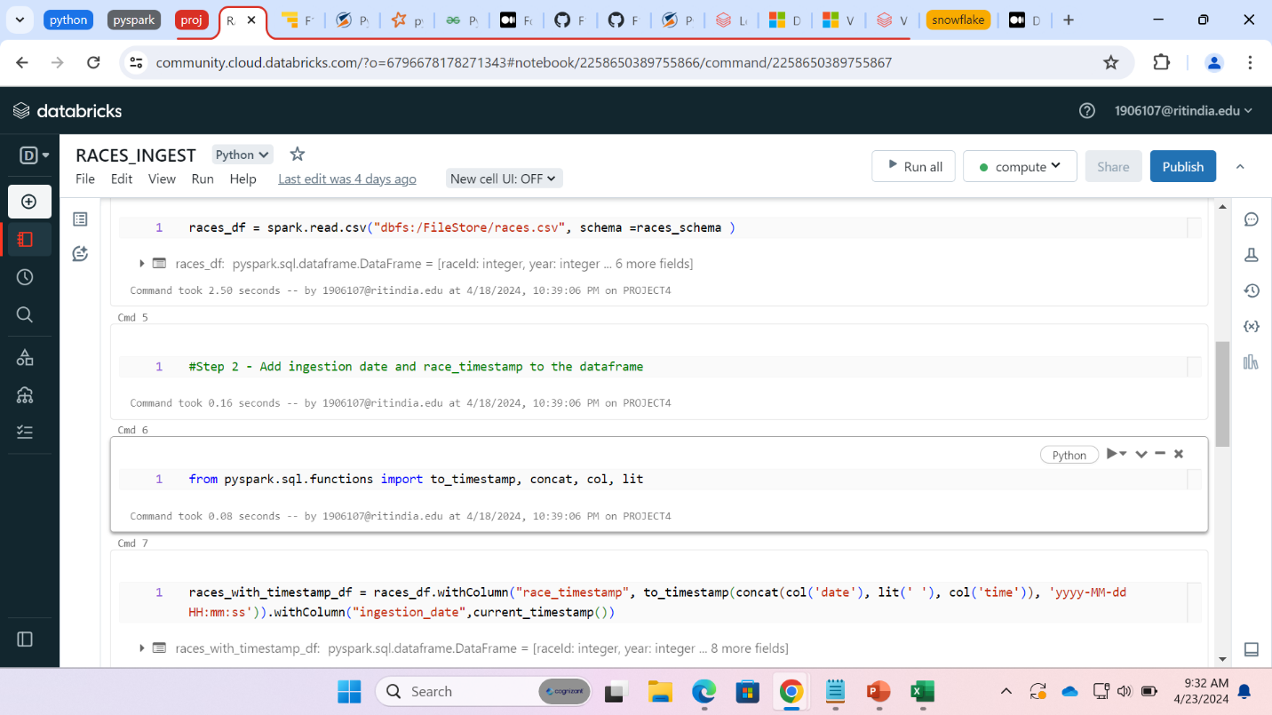

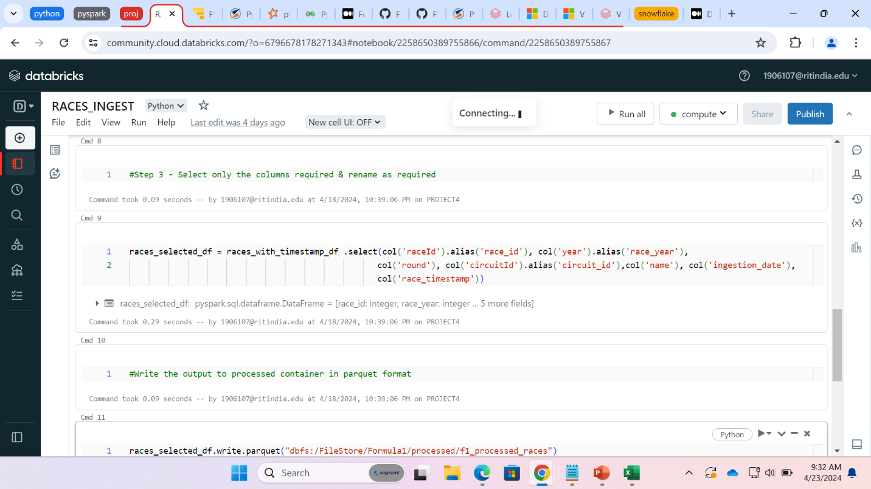

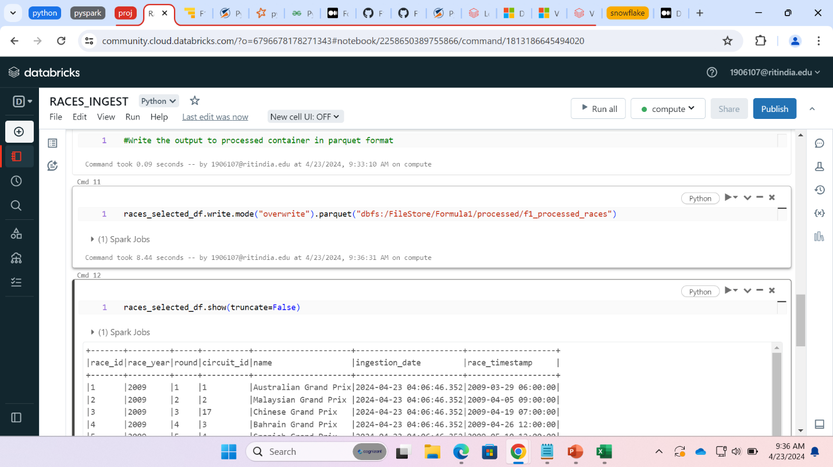

**Result file ingestion**

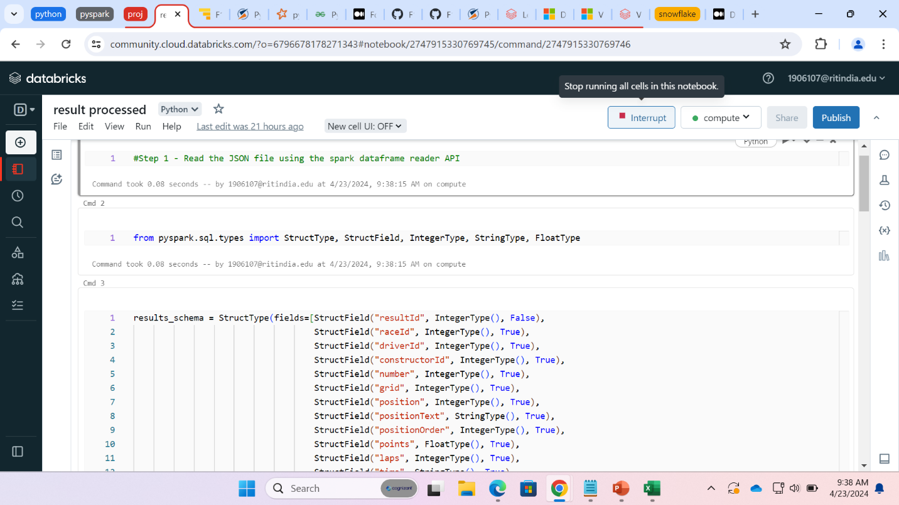

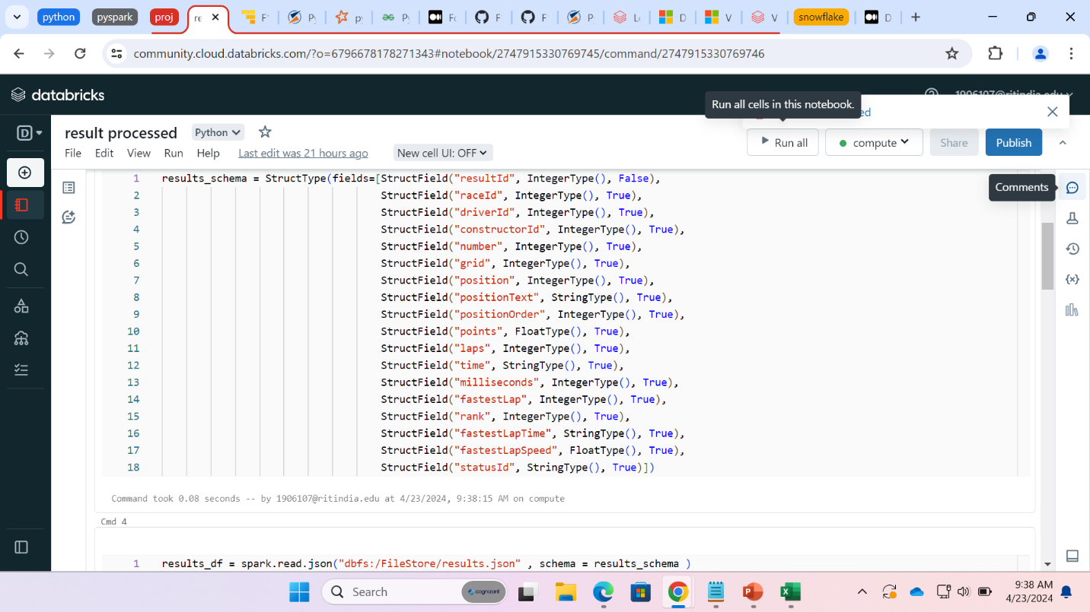

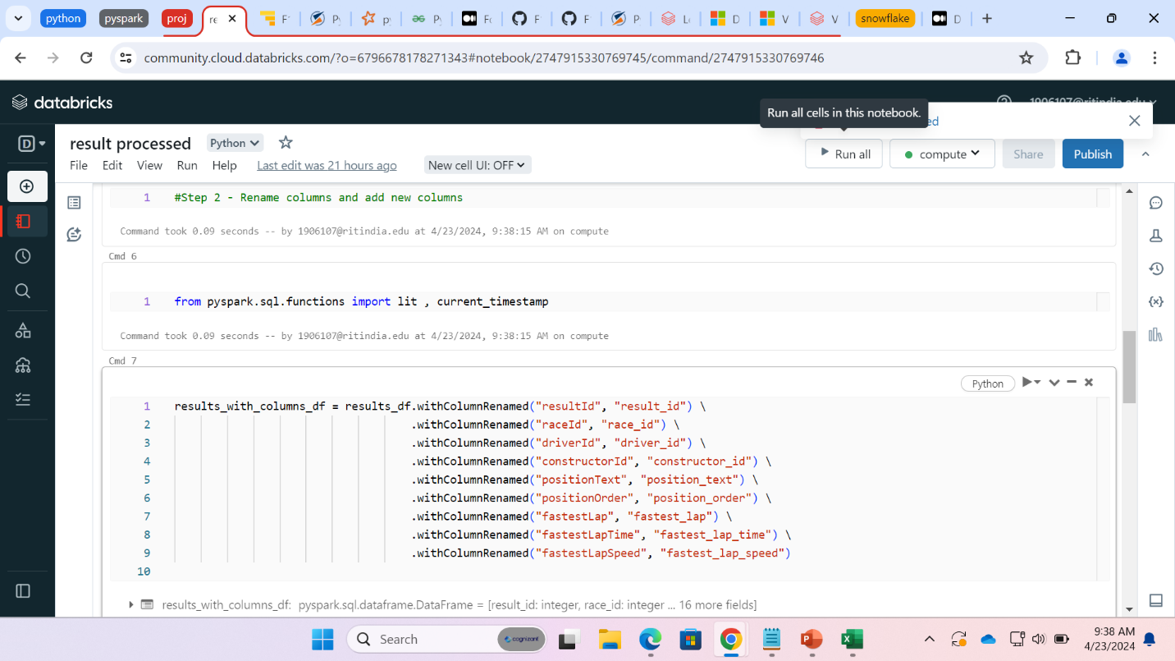

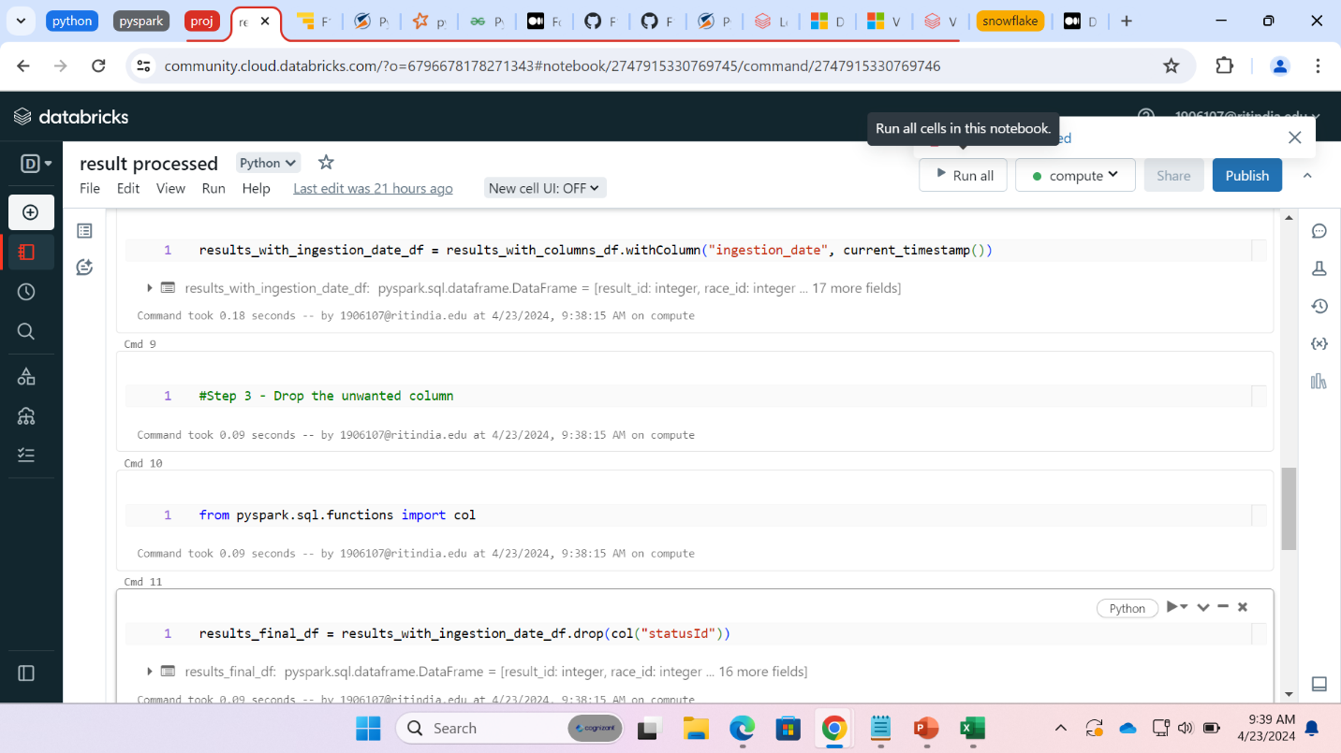

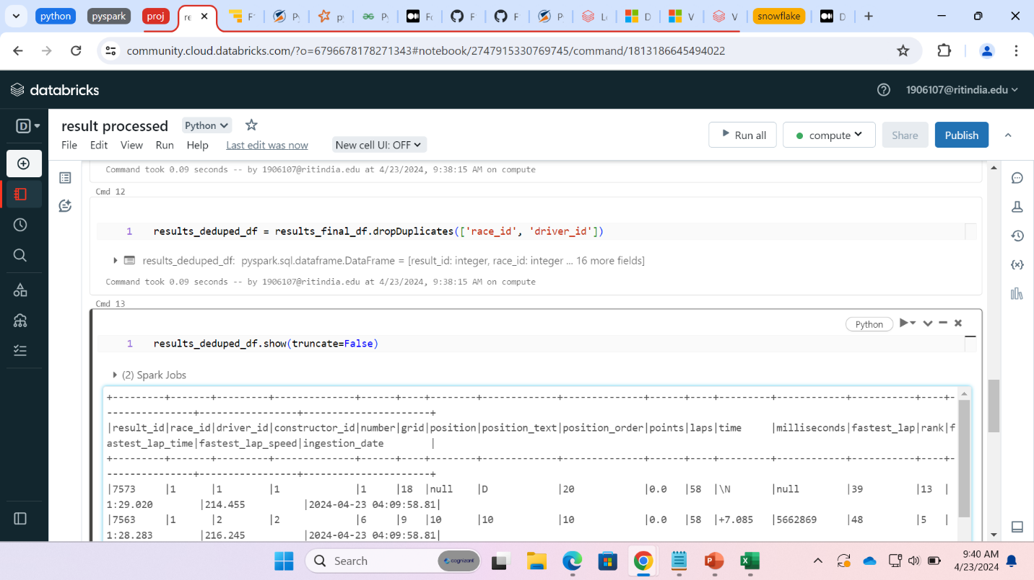

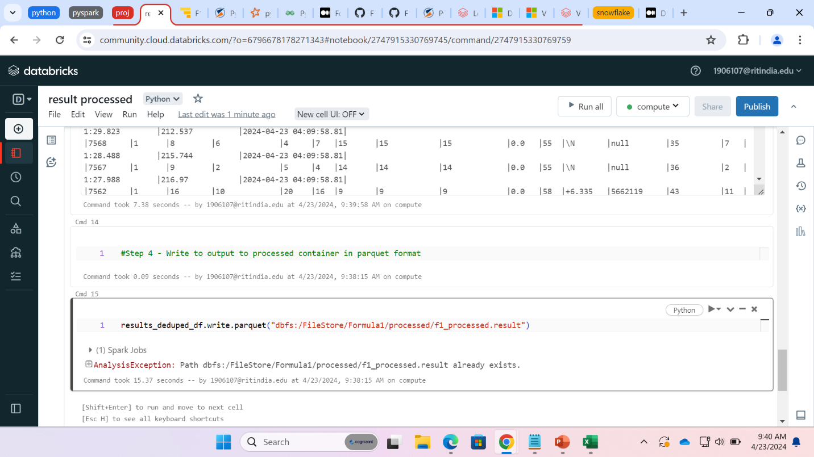

* **REQUIREMENT 2:**

**Step 1: Read all the parquet files from dbfs file store**

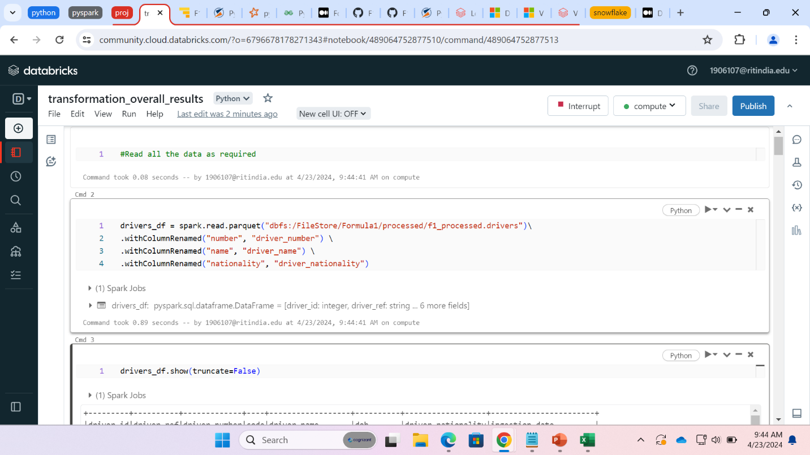

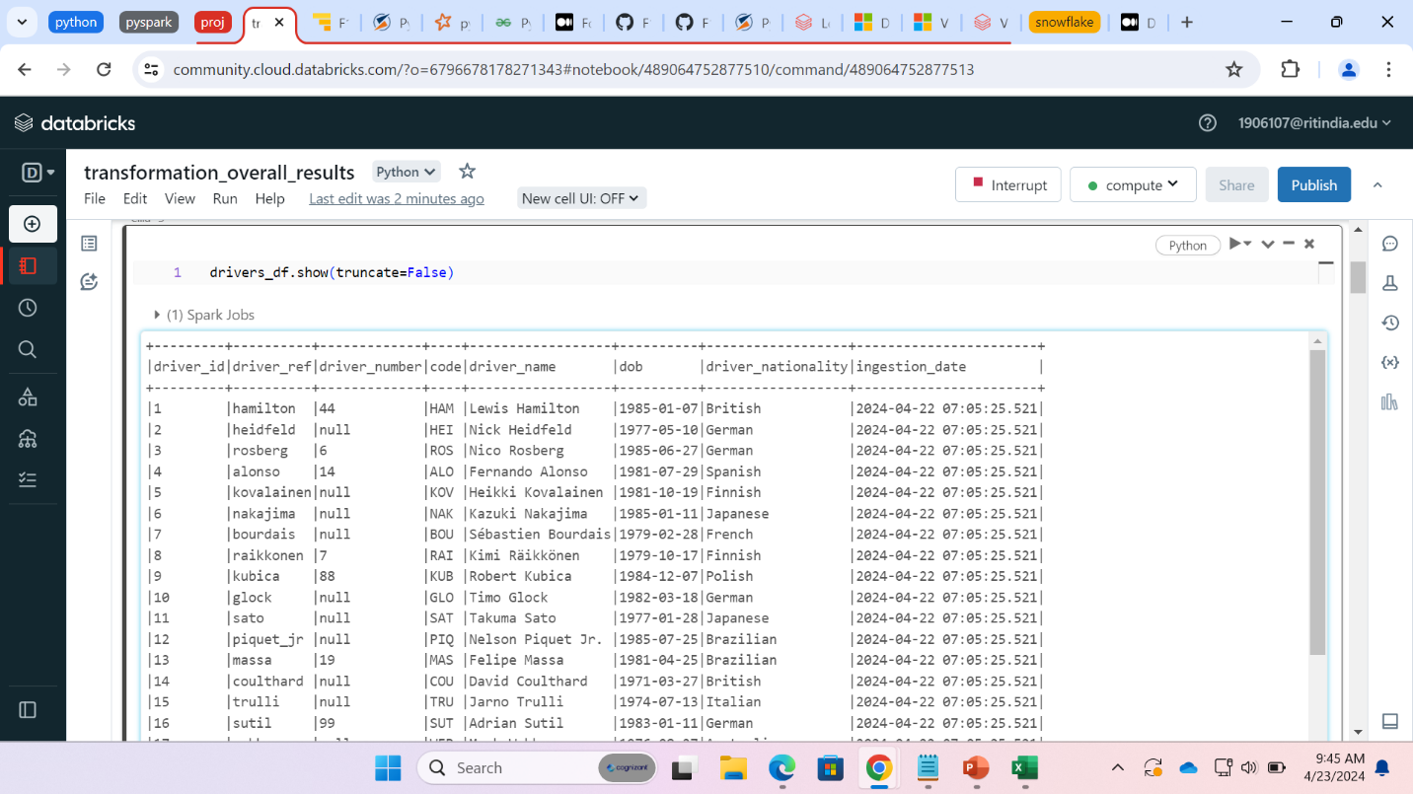

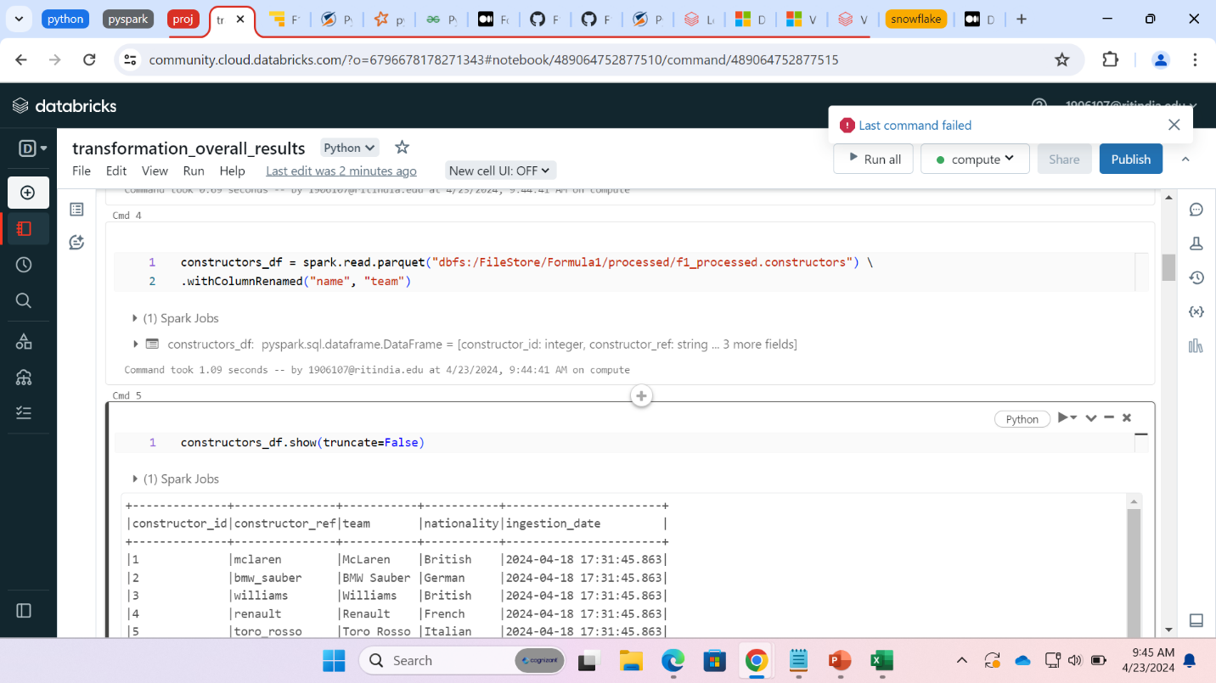

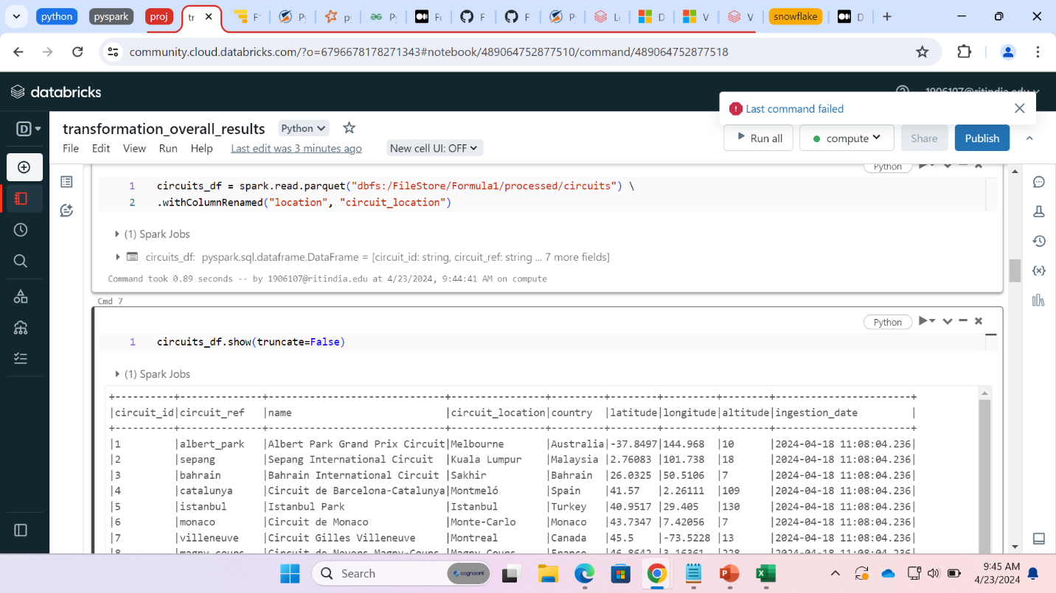

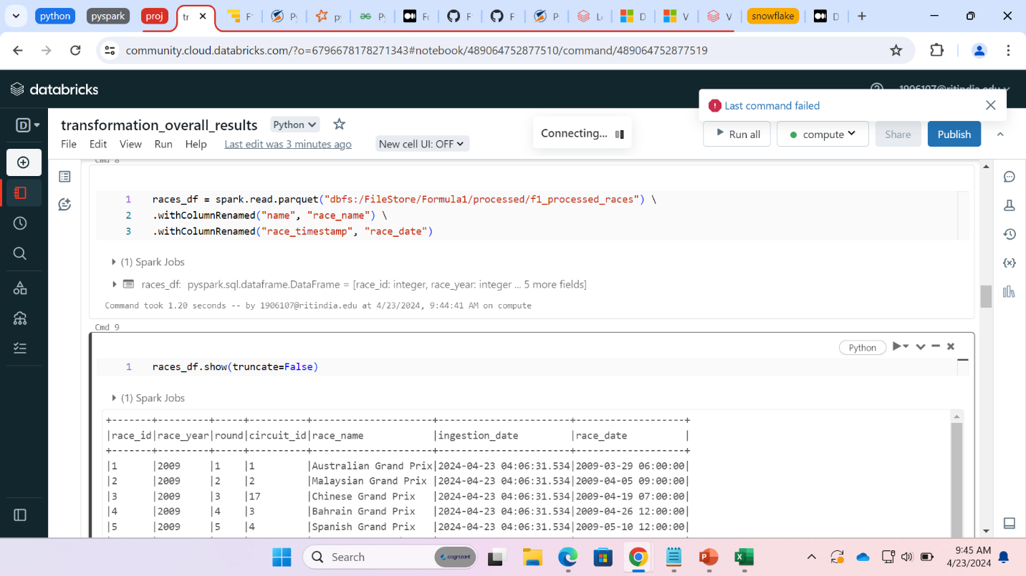

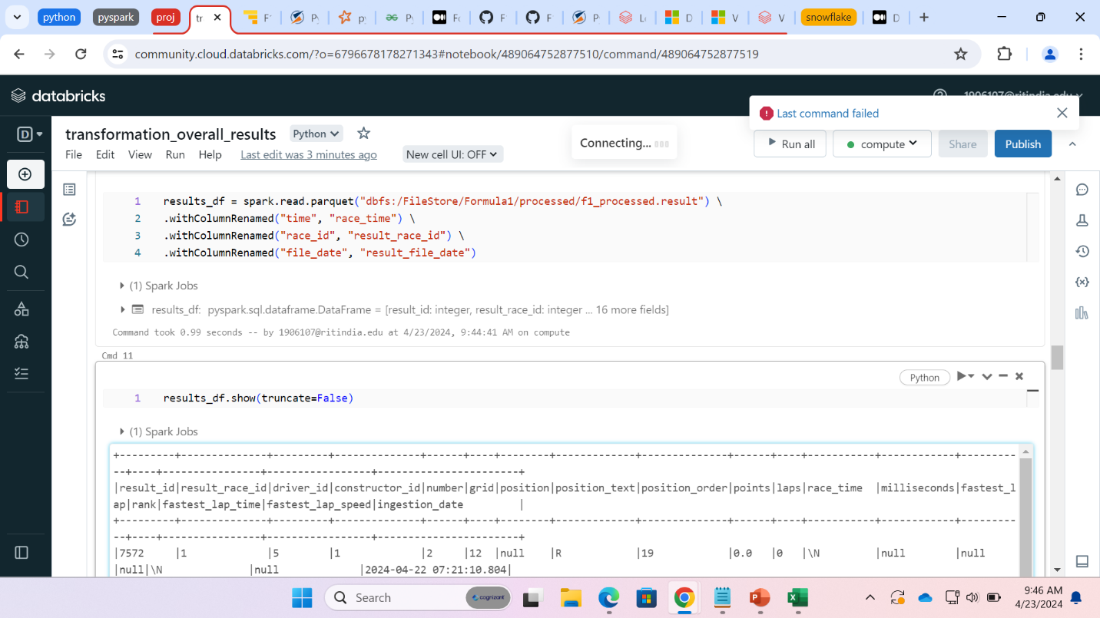

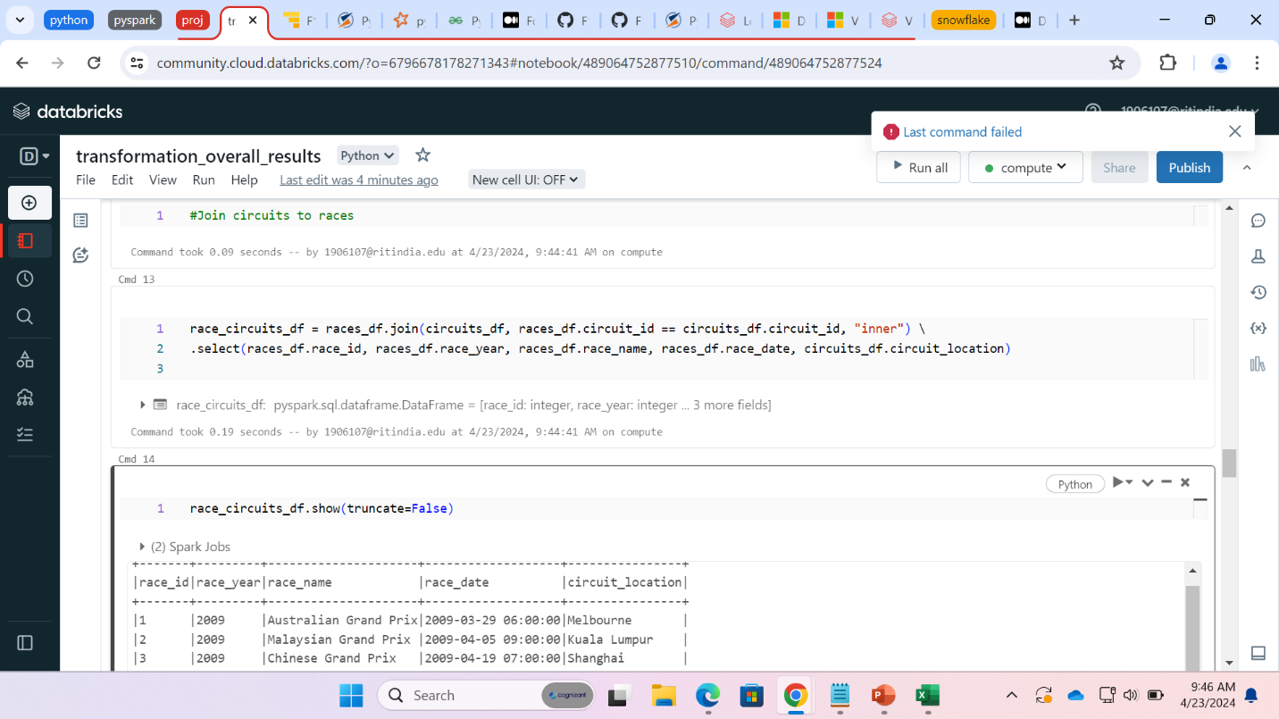

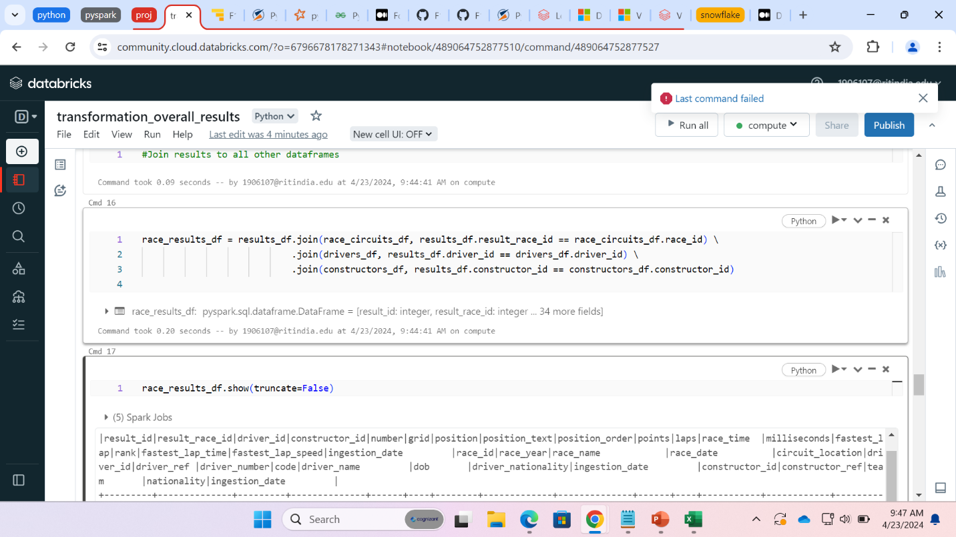

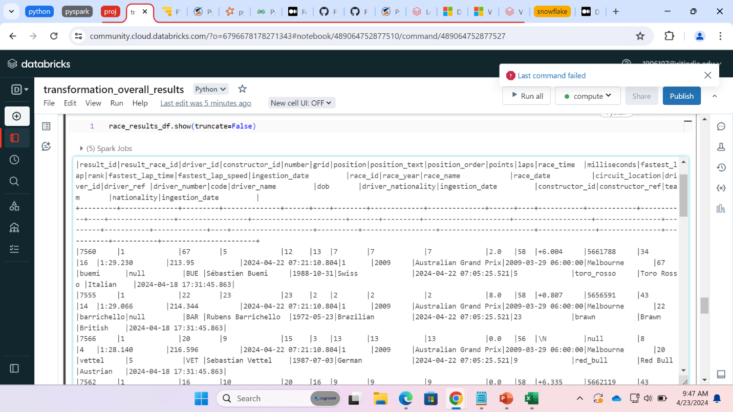

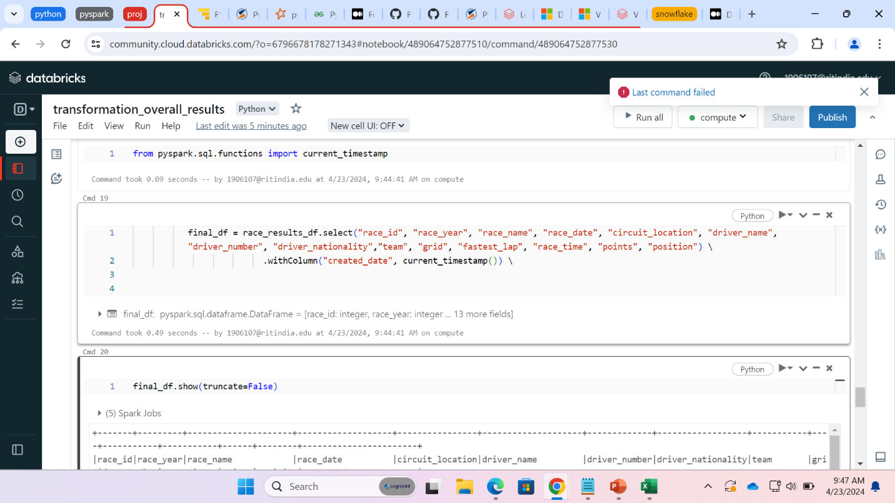

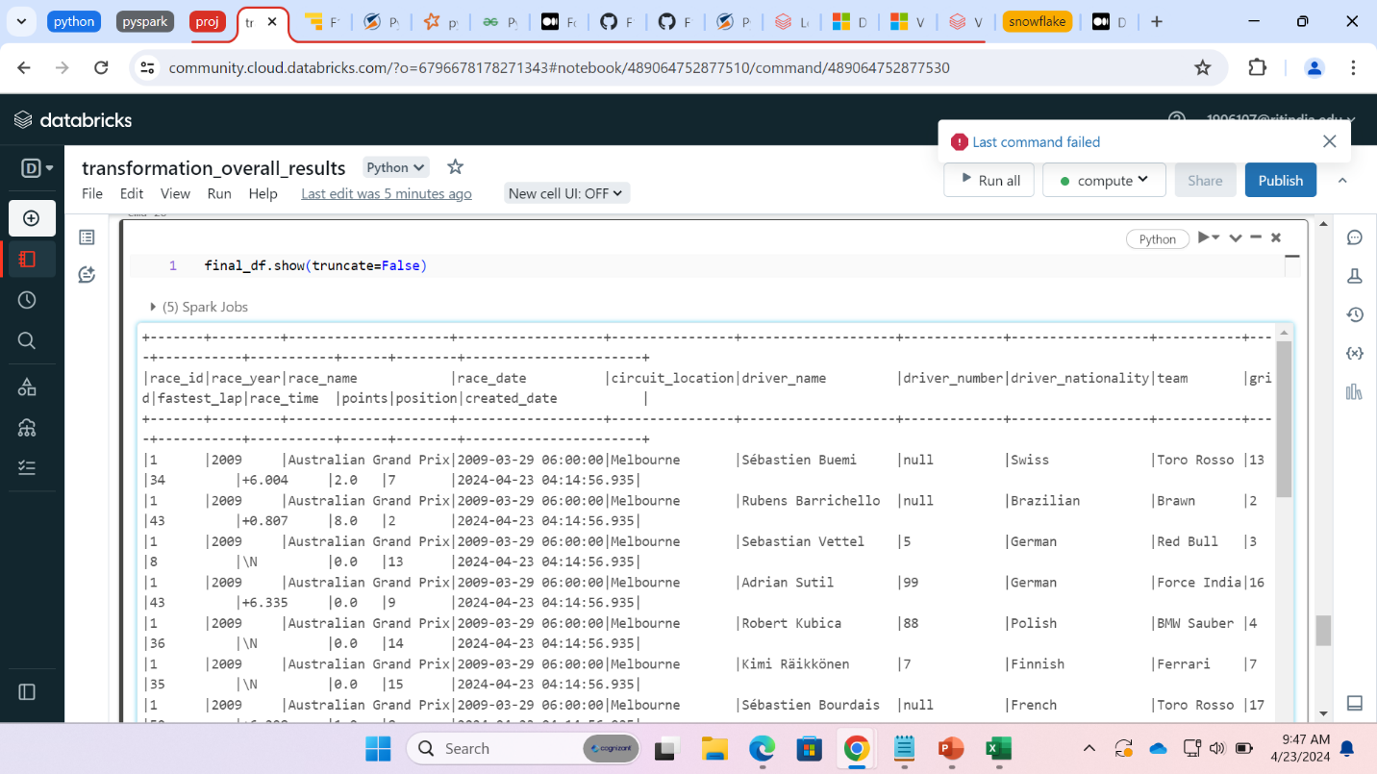

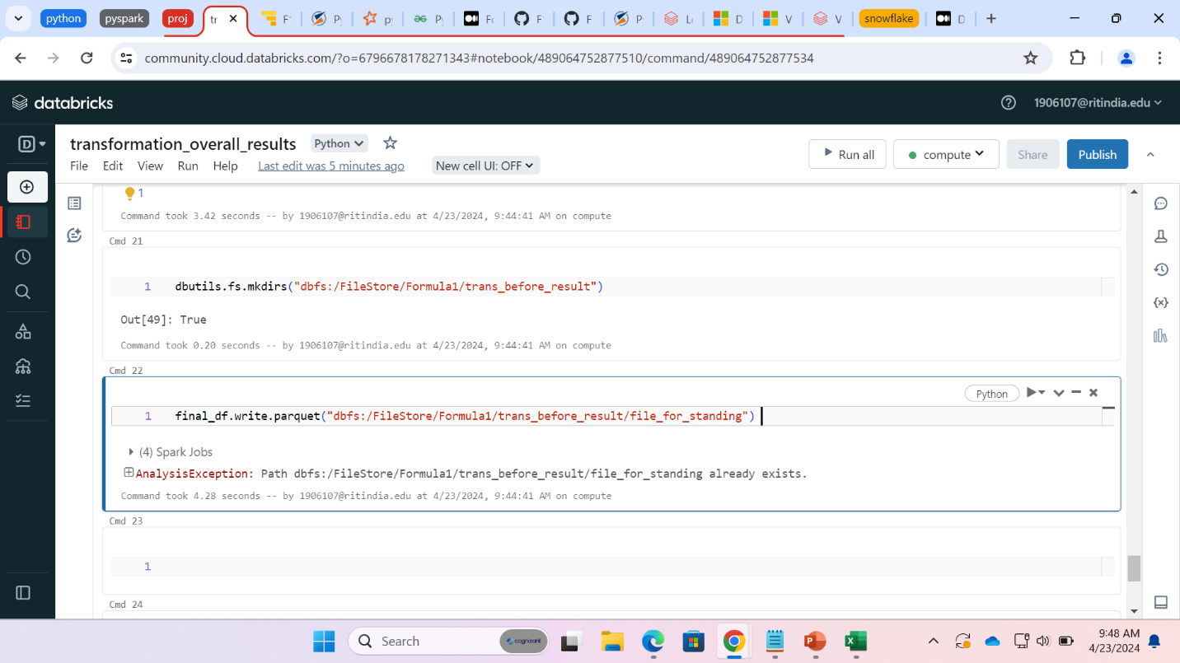

Constructor standing and dominant team

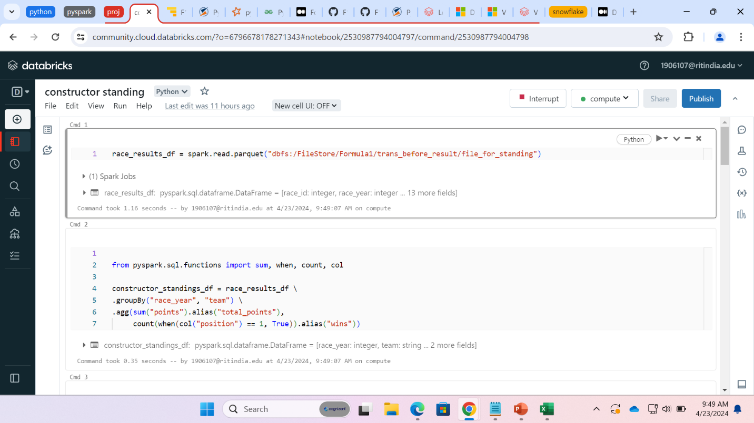

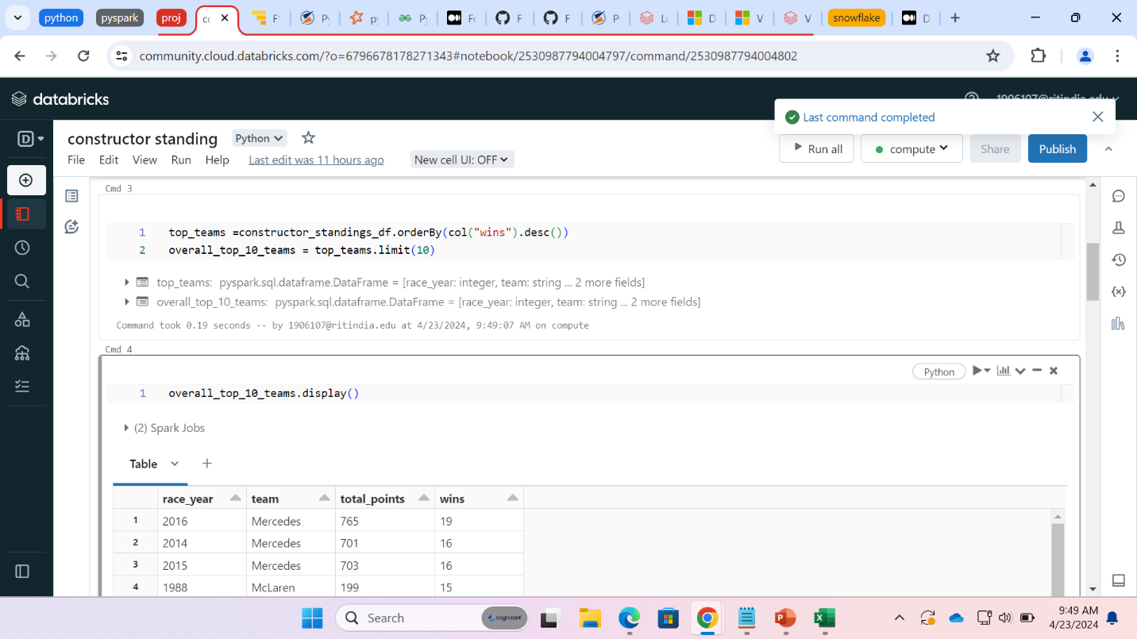

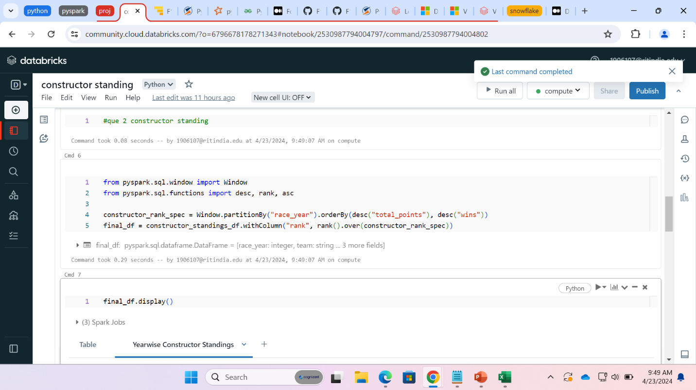

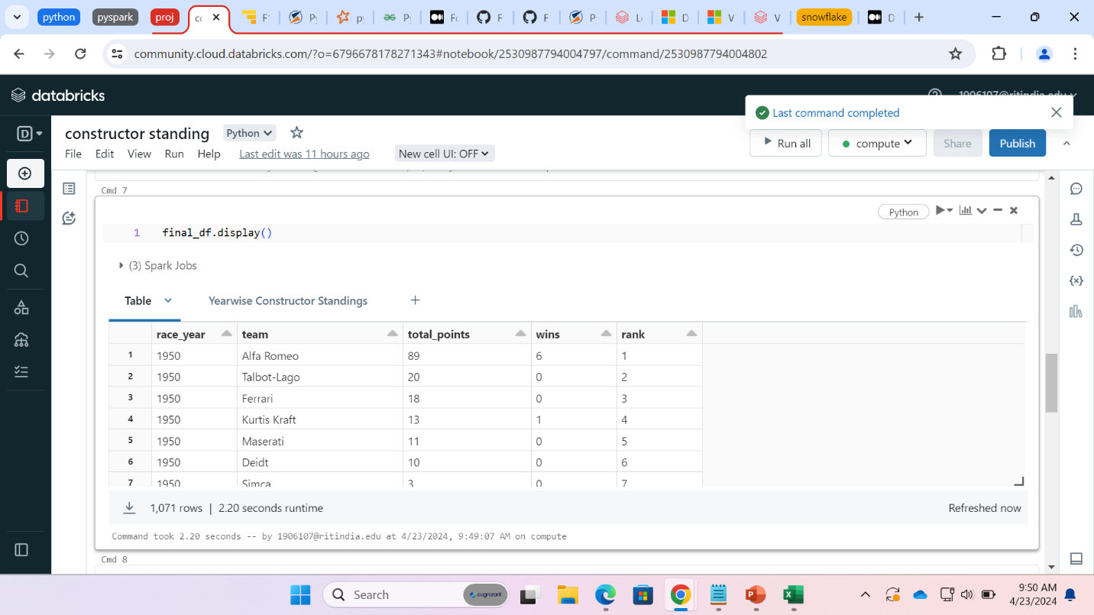

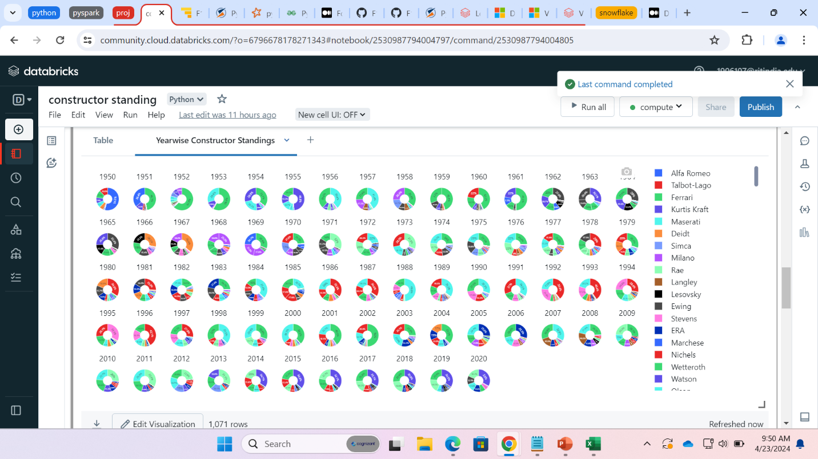

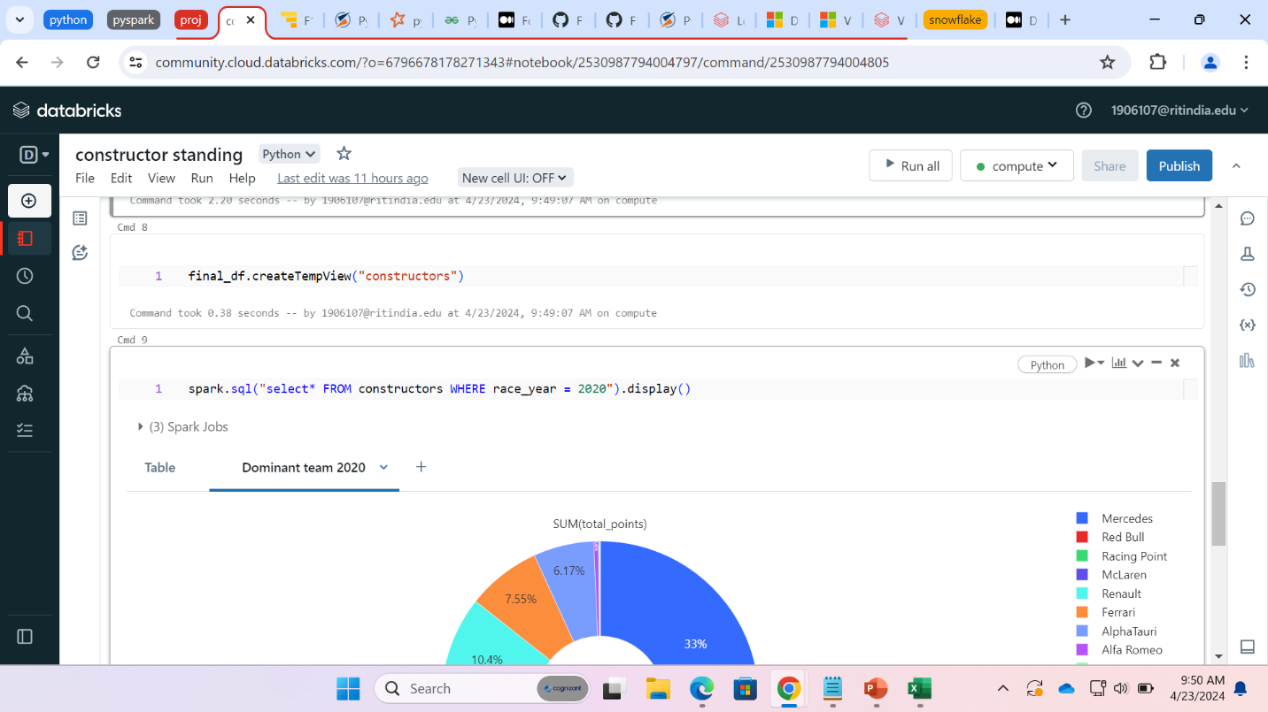

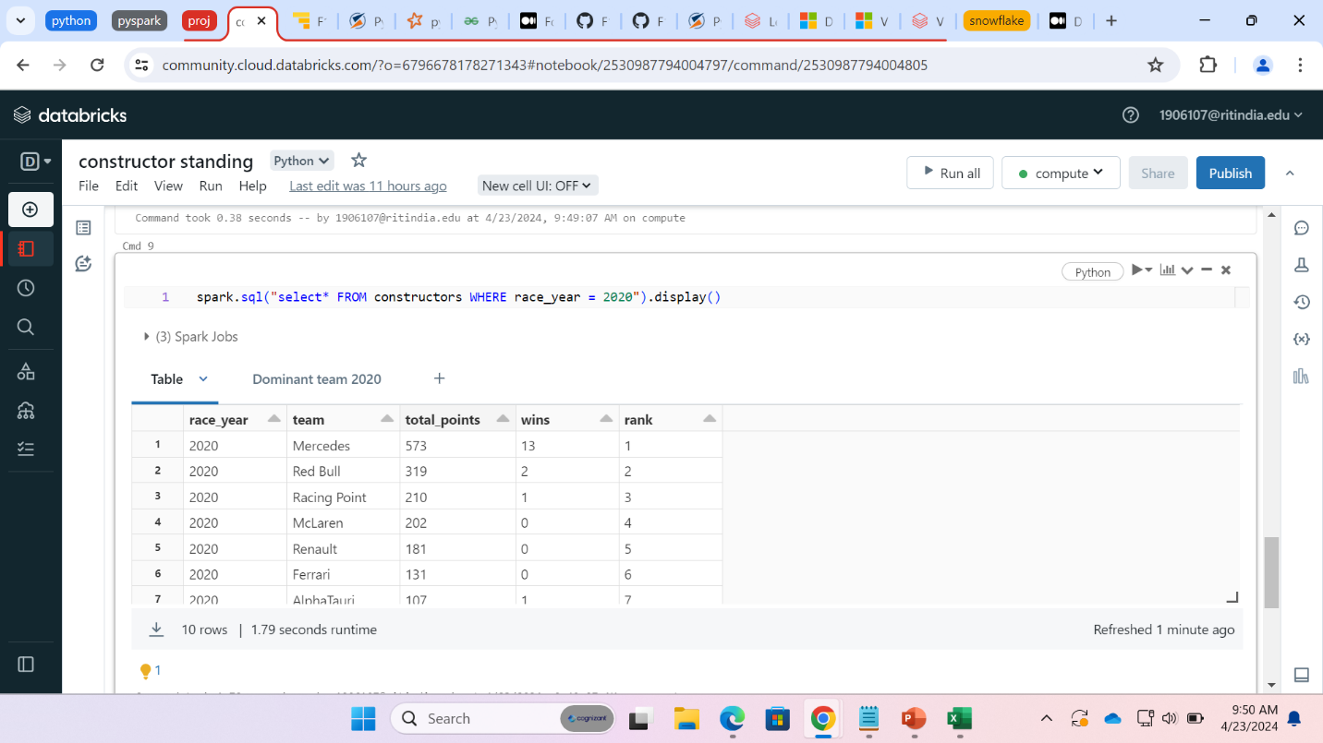

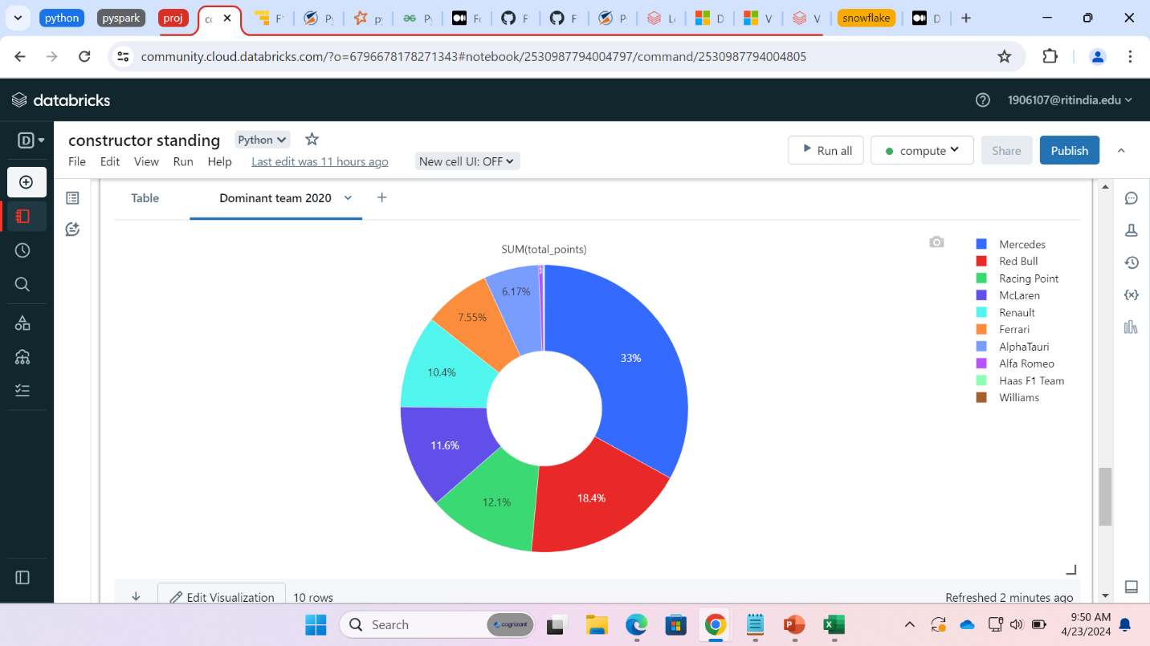

Driver standing and dominant driver

